WEEKLY HIGHLIGHTS July 12, 2024
We are in week four of the Summer of Learning programs. There is energy and learning across all Regions throughout the various programs.

- 114,480* unique student enrollment for all Summer of Learning Programs (as of 7/12/24)

SUMMER SCHOOL SURVEYS
We hope that summer school has been a pleasant experience for all. As we close summer programs, we would like your feedback. Your opinion matters to us, and we strive to continuously improve our programs and services based on our stakeholders' valuable feedback.

- Please distribute survey fliers with QR codes to staff, students(Grades 4-12), and families.
- Click the appropriate link for access to the surveys: bit.ly/SummerSchoolSurvey2024

For more information, please contact Tyra Henderson, Director of Elementary Instruction at tbrookin@lausd.net.

SUMMER SCHOOL, UTK-8
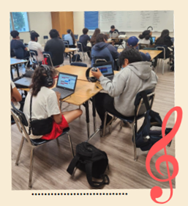
UTK-8 students had an exciting week! Over 2,300 students participated in a Day of Discovery outdoor learning experience. This week’s highlights include:
- Columbus Avenue Elementary School students received a surprise visit from the Los Angeles Football Club’s (LAFC) Falconer Program and learned about urban raptors, biomimicry, and wing design.
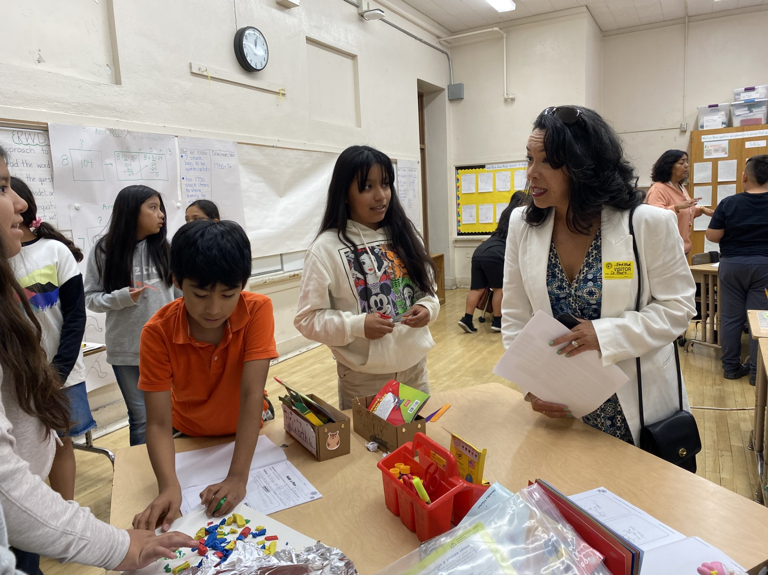
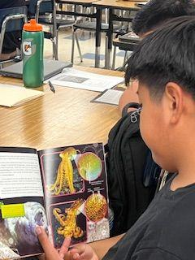
- Students at Stevenson CCP created music beats through Soundtrap and learned about volume, looping, and fade-in/out. Their culminating project will be a soundtrack that includes various music genres such as jazz, rock, heavy metal, and hip hop.
- Dr. Baez visited Purche Elementary School and Ford Boulevard Elementary School, participated in classroom observations, and engaged with students.
- 3,090 classroom observations using the UTK-8 Classroom Observation Tool
- 134 Day of Discovery outdoor learning field study experiences provided for UTK-8 students
- 24,097 unique student enrollment for UTK-8 Programs (as of 7/12/24)

For more information, please contact your Summer School Principal OR
Ana Estevez, Director Beyond the Bell, at ana.estevez@lausd.net. Thank you!

SUMMER CONTINUITY OF LEARNING FUN
Continuity of Learning is available to students and families from June 24 - August 11, 2024.

- 66,372 unique users have accessed Continuity of Learning Lessons (as of 7/12/24)
- Unique participation by region: North 19,821, South 14,376, East 20,316, West 10,295, XS-1,564
- 📺 How to access learning activities: Video

For more information, please visit our Summer School website: Website or contact Tyra Henderson, Director of Elementary Instruction at tbrookin@lausd.net.

#LAUSD #SummerLearning #KeepLearning #EducationForAll

HIGH SCHOOL SUMMER TERM
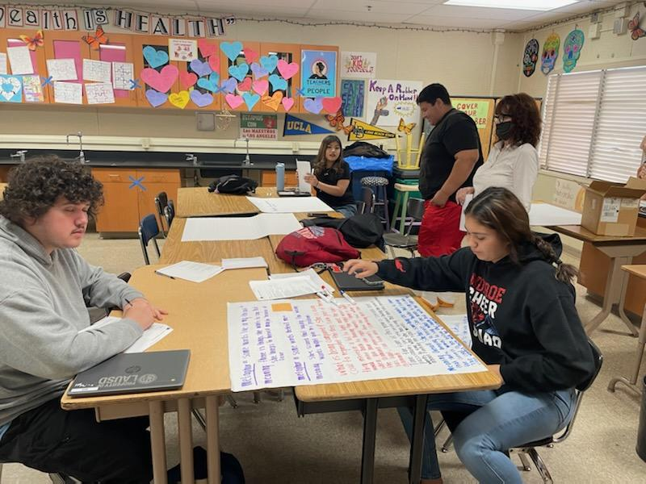
This week’s High School Summer Term program highlights include:

Northridge Academy HS mathematics teacher working with small groups
of students on problem-solving and graphing linear inequalities. The Smart Start Tutor provides additional instructional support walking around the classroom and helping students.

Monroe HS English teacher reads the poem "Coal" aloud to the class.
Students then work in small groups to analyze the poem. Presentations are
conducted by each group of students who present their ideas aloud to the class.
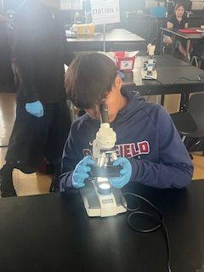
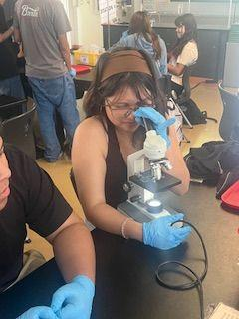

Garfield HS Biology students engage in a science lab with live specimens, increasing engagement and deepening their understanding.

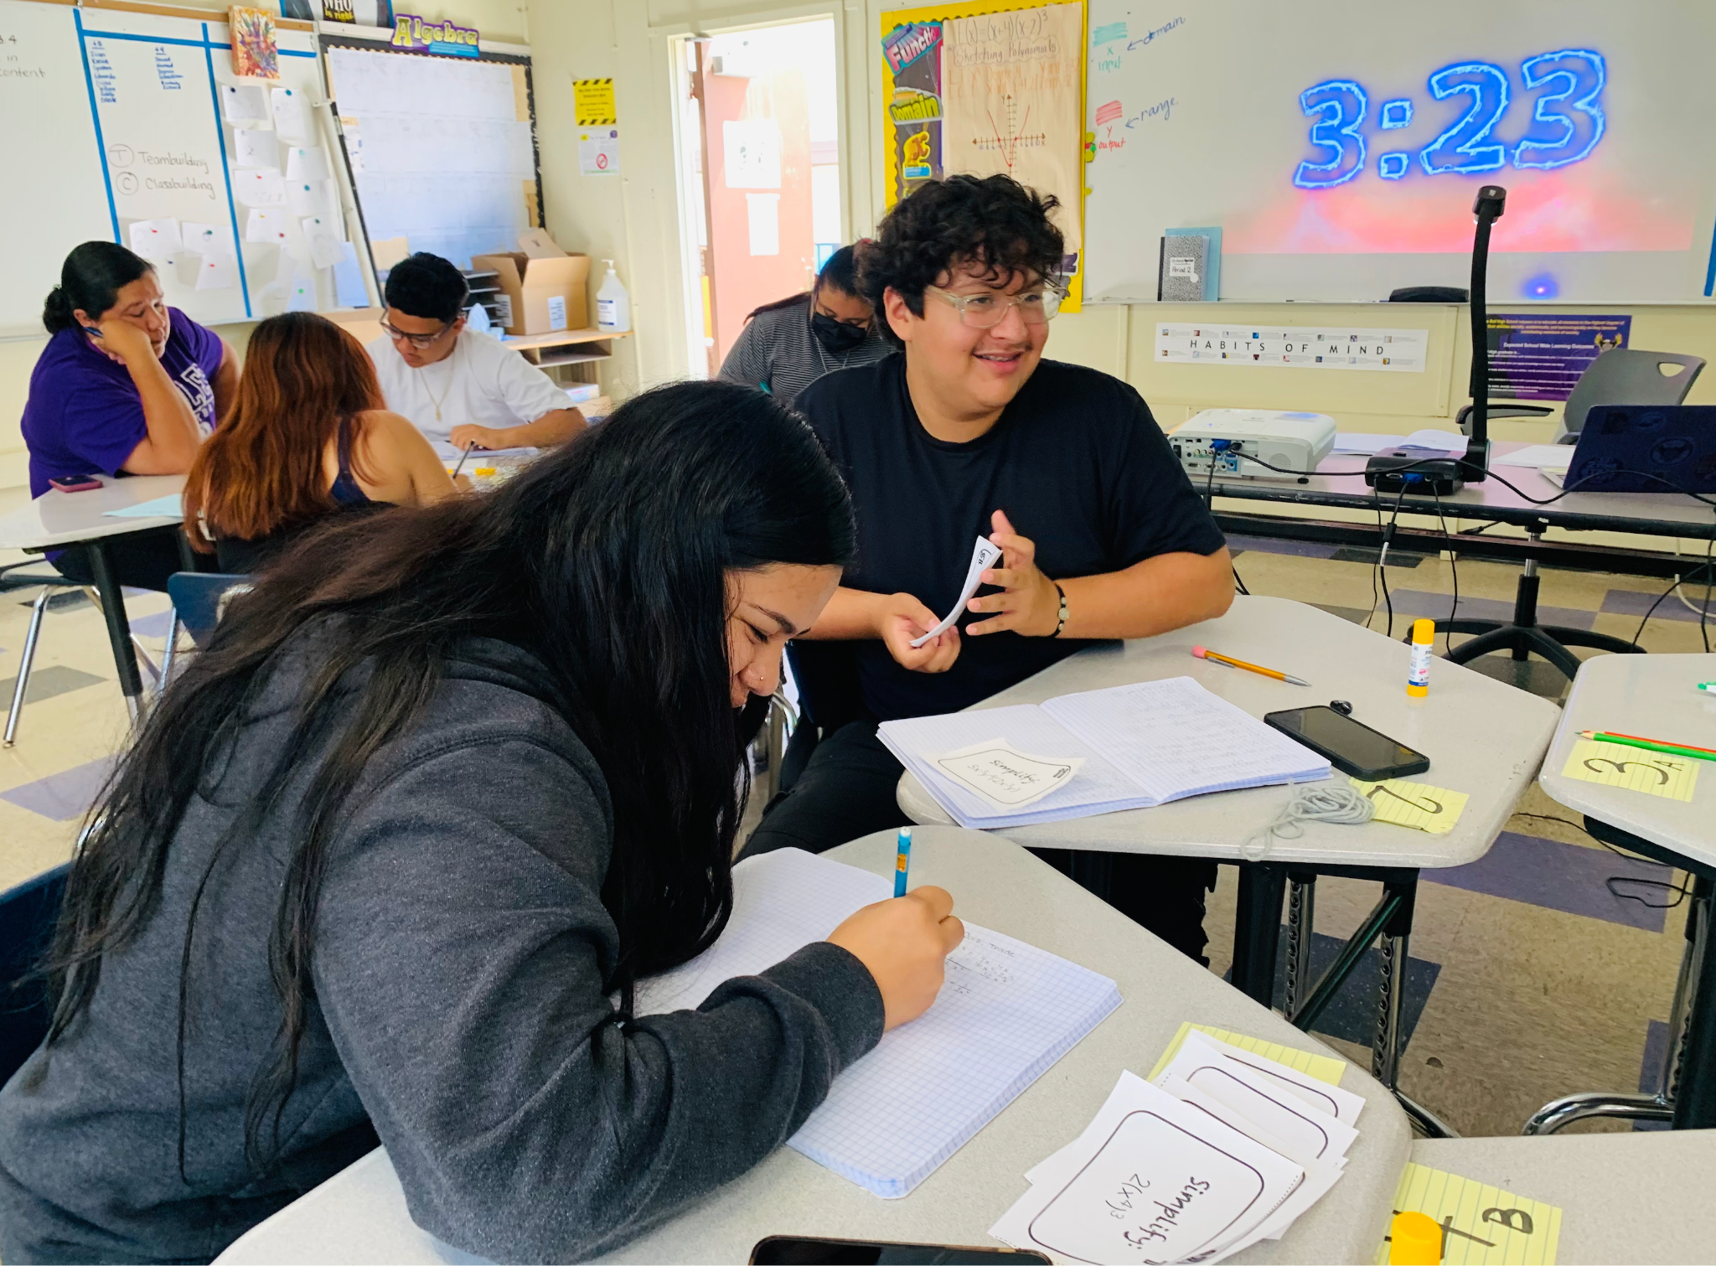
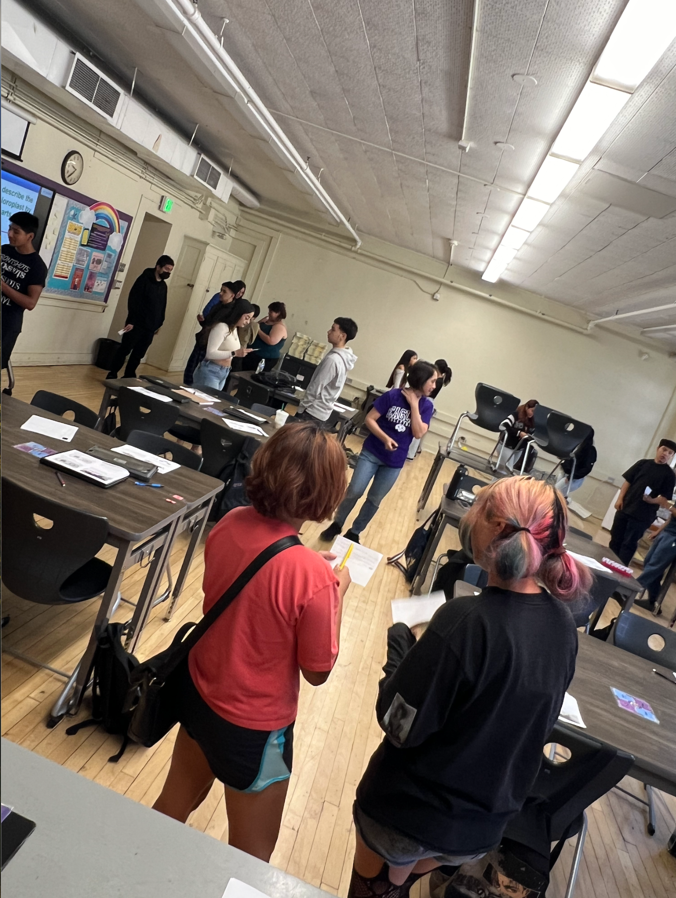
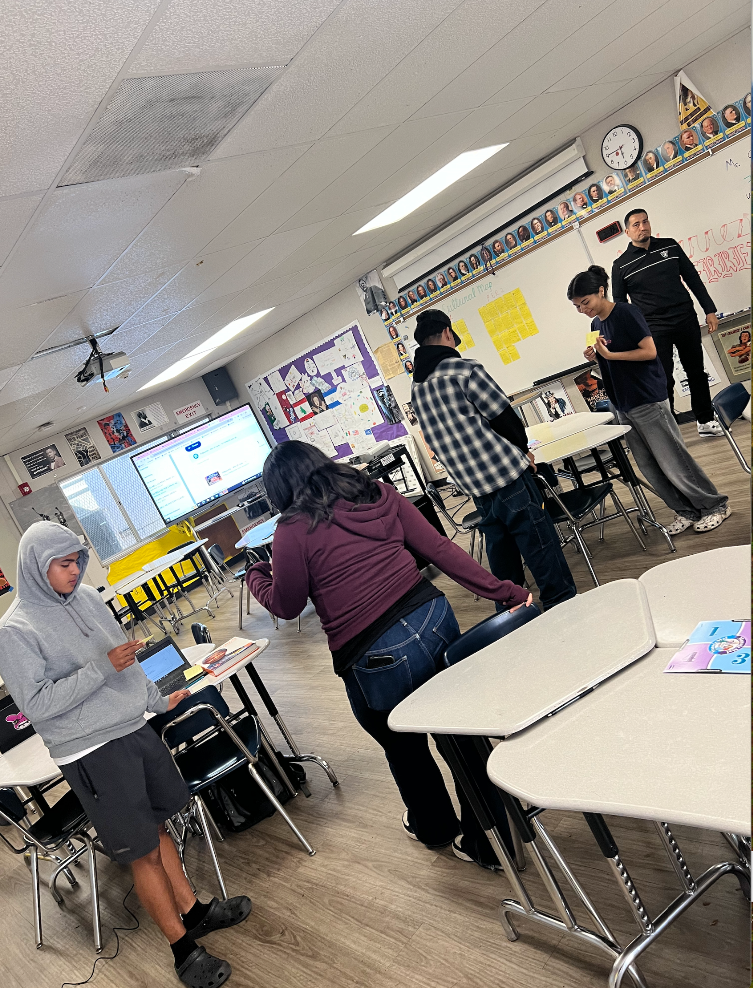
Bell HS students engage with each other and content using Kagan structures across the content areas. The images include the implementation of Quiz-Quiz-Trade on Equivalent Forms in an Algebra 2 Class, Think/Write/ Stand Up/Hand Up/ Pair Up to share their Biology responses with their partners, and Mix-Pair-Share in World History to share key facts about the 4th of July. It is great to see teachers implementing professional development.

- 1,742 classroom observations as of 7/12/24 using the High School Classroom Observation Tool
- 20,417 unique student enrollment for High School Summer Term In person (as of 7/12/24)
- 19,978 unique student enrollment for High School Summer Term Virtual (as of 7/12/24)
For more information, please contact your Summer School HS Principal, counselor, or Dr. Betsy Castillo, Director, Beyond the Bell at bac9874@lausd.net.

JO BOALER MATH CAMP
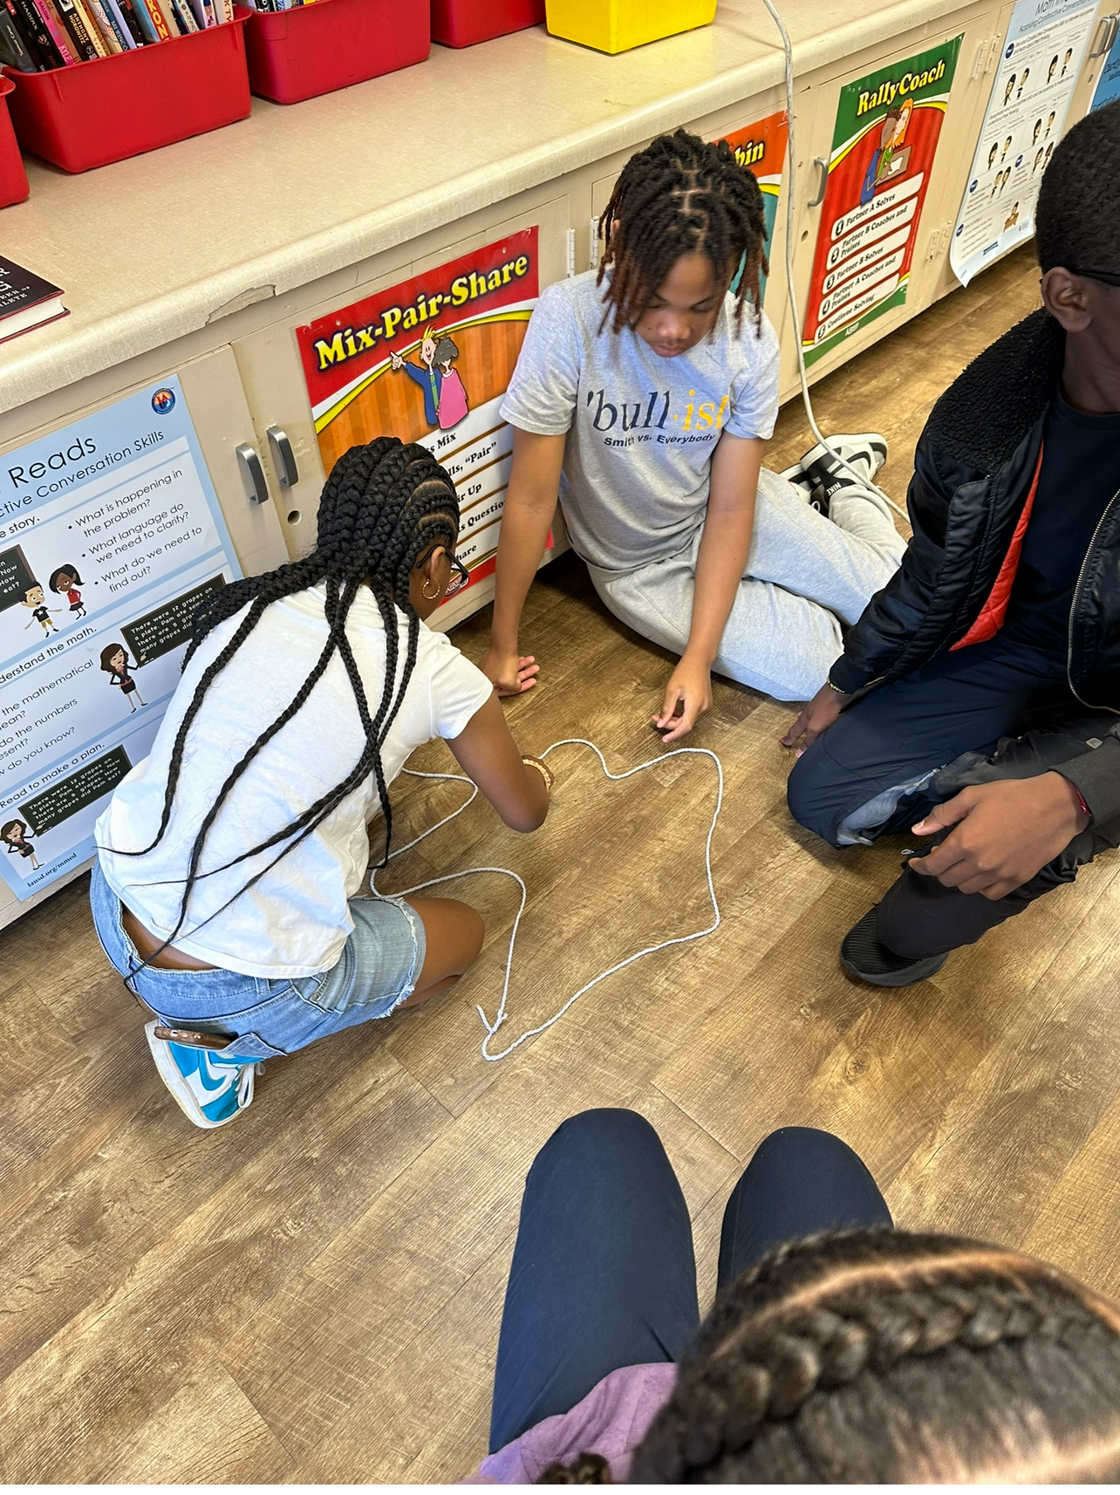
This week, we are highlighting Wright MS, Region West. Students are using non-traditional mathematical methods to develop critical thinking and problem-solving skills.

- 102 unique student enrollment for Jo Boaler Summer Math Camp (as of 7/12/24)

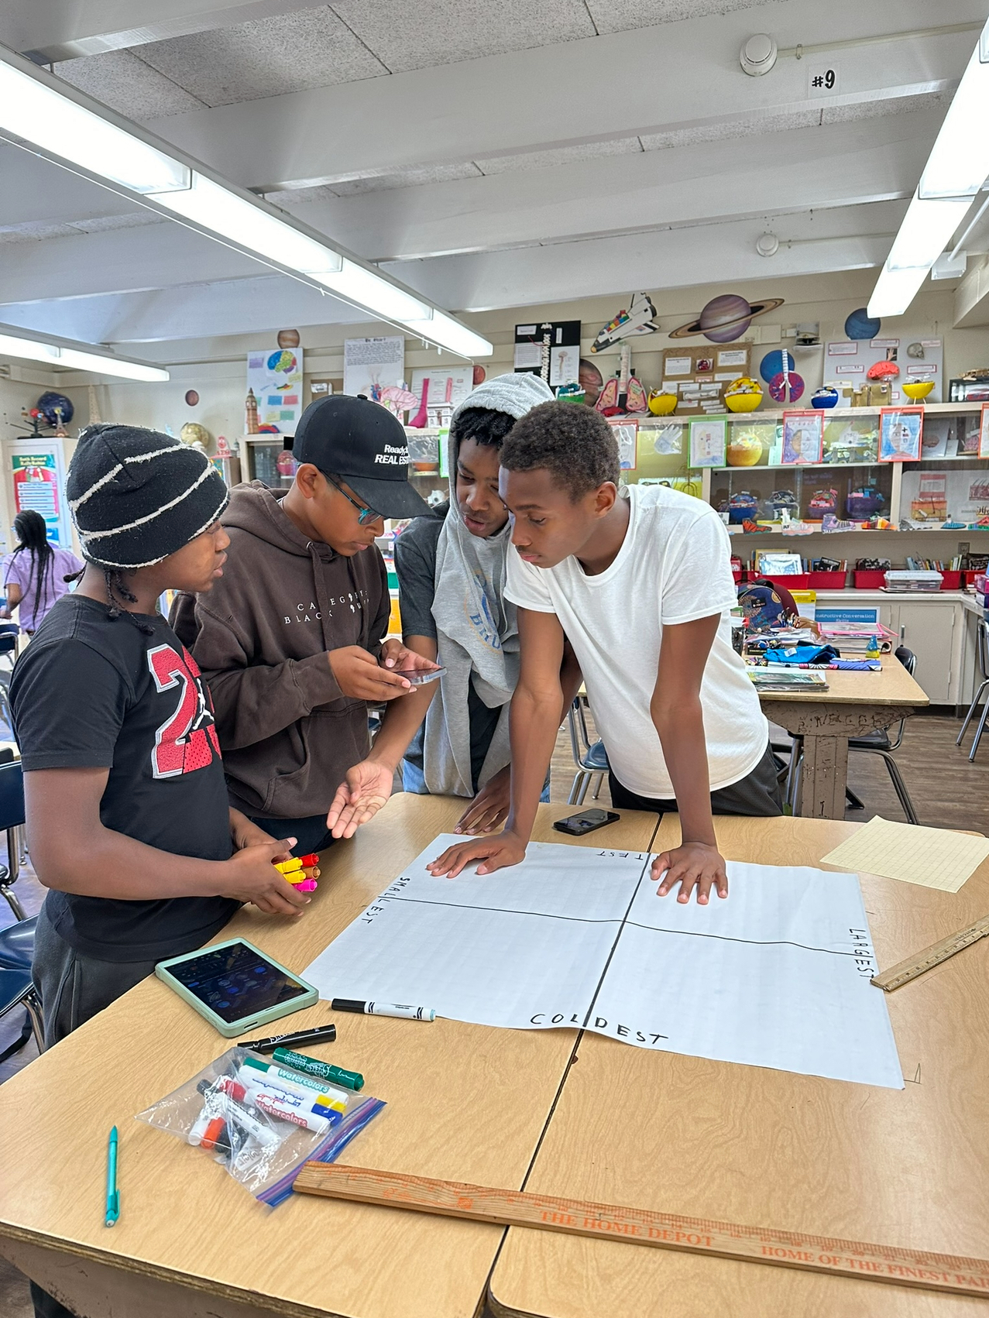
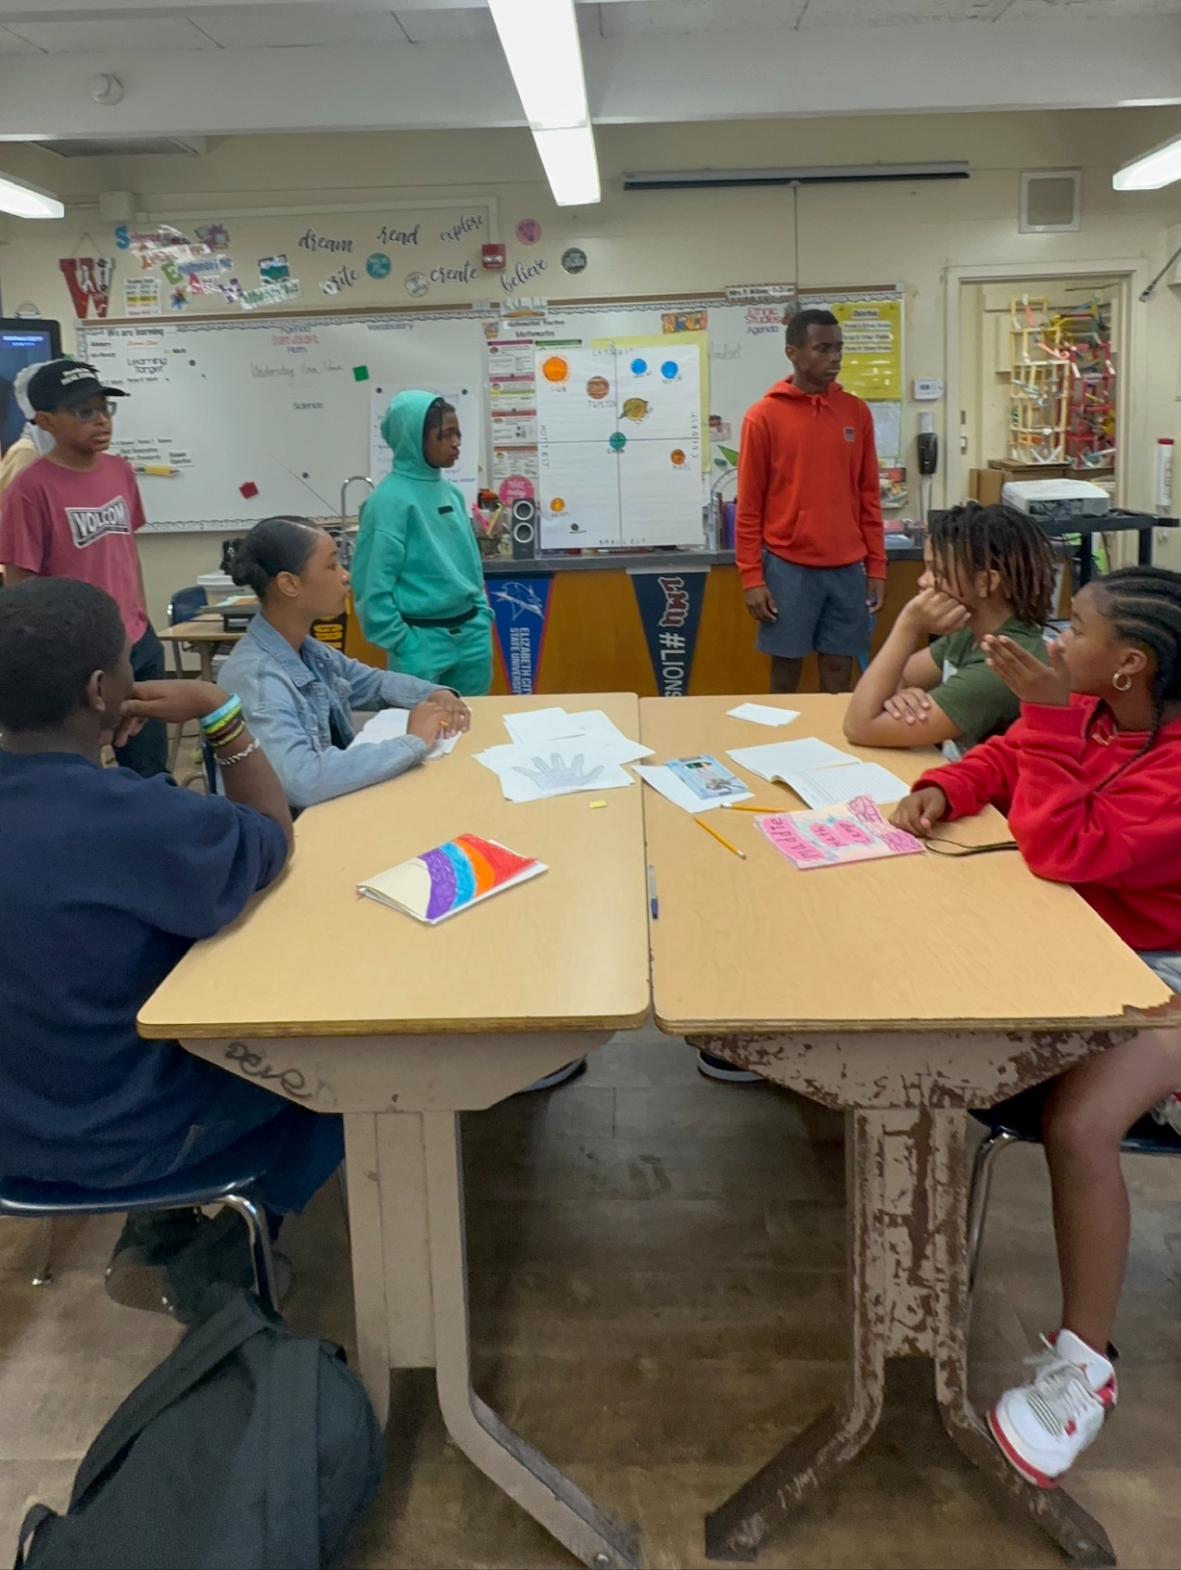
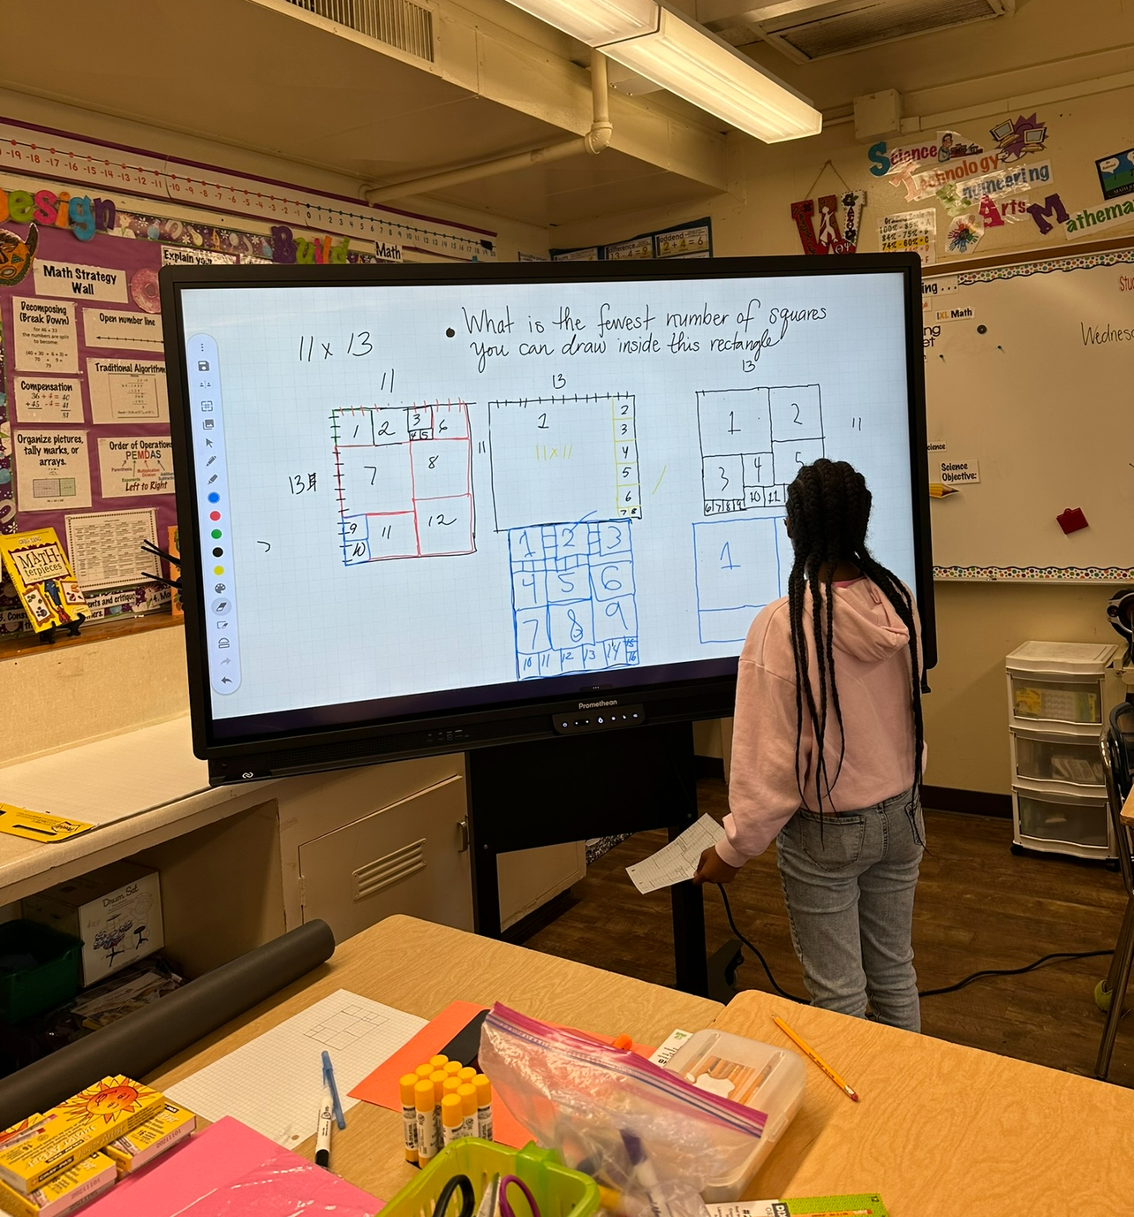
For more information, please contact Chiae Byun-Kitayama at cbyun1@lausd.net

BRIDGE PROGRAMS
SUMMER BRIDGE MIDDLE AND HIGH SCHOOL READINESS PROGRAMS
The Bridge Readiness Programs offer incoming middle and high school students a comprehensive readiness experience. These programs aim to prepare students for academic success, nurture their identity, foster new relationships, engage in social-emotional learning, and ignite motivation for the upcoming academic year.

- 60 MS, 52 HS and 18 Span Schools (130 Total) offering Bridge Readiness Program during summer
- 10,122 estimated unique student enrollment for upcoming July/August Bridge Programs (as of 7/12/24)
- Attendance for the week of July 12: 76 (2 schools offering programs this week)

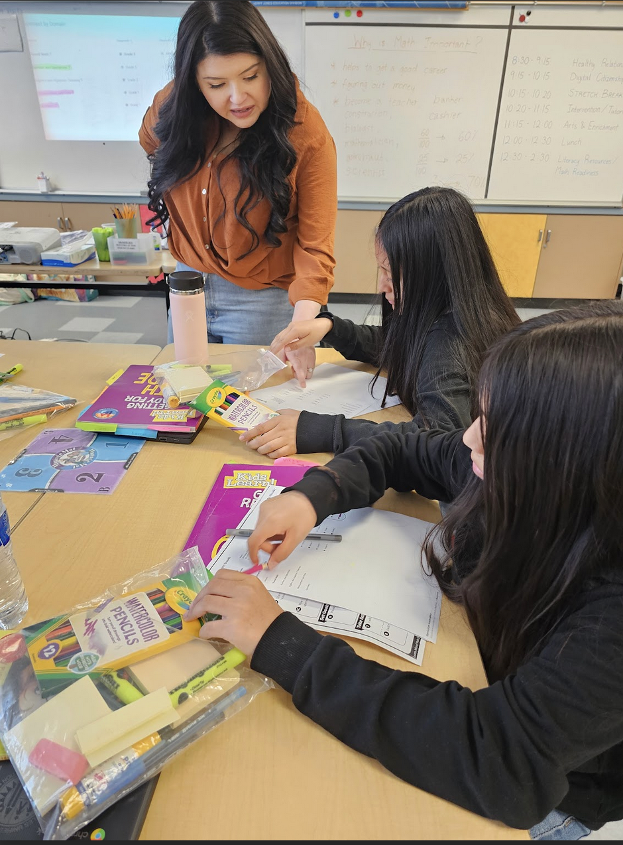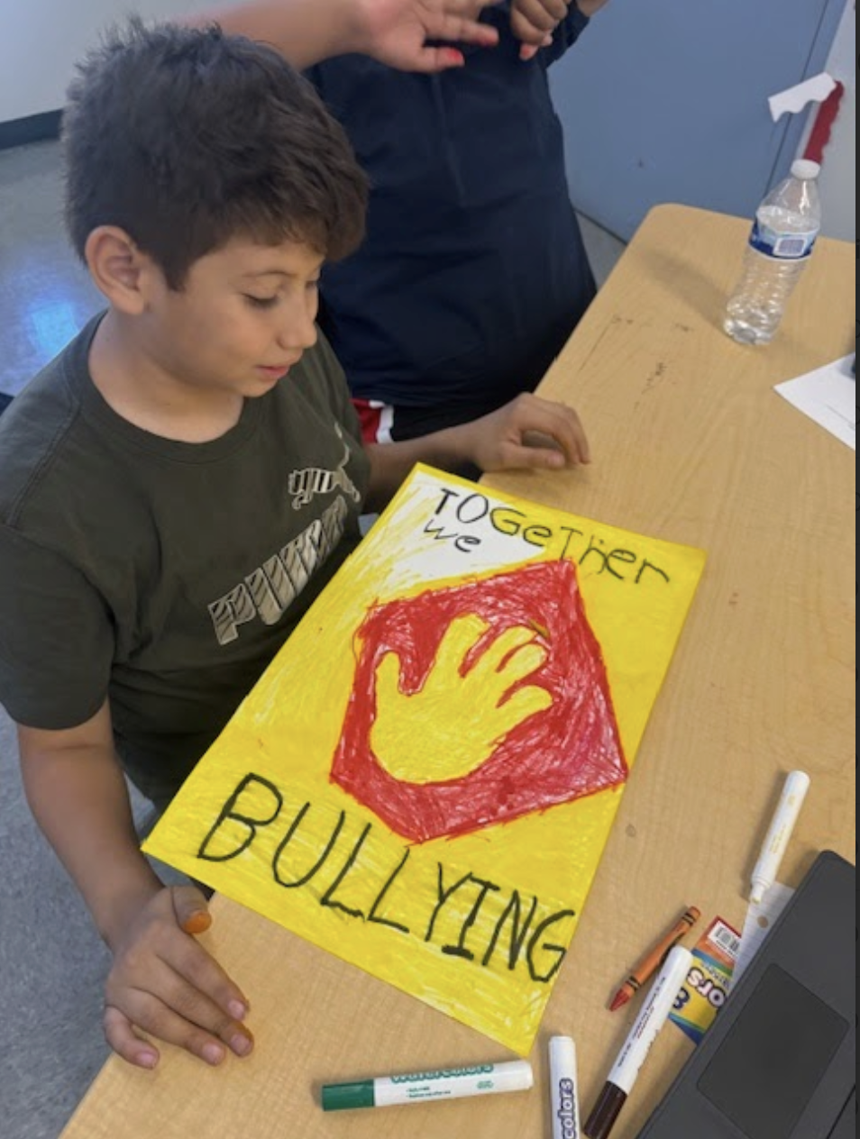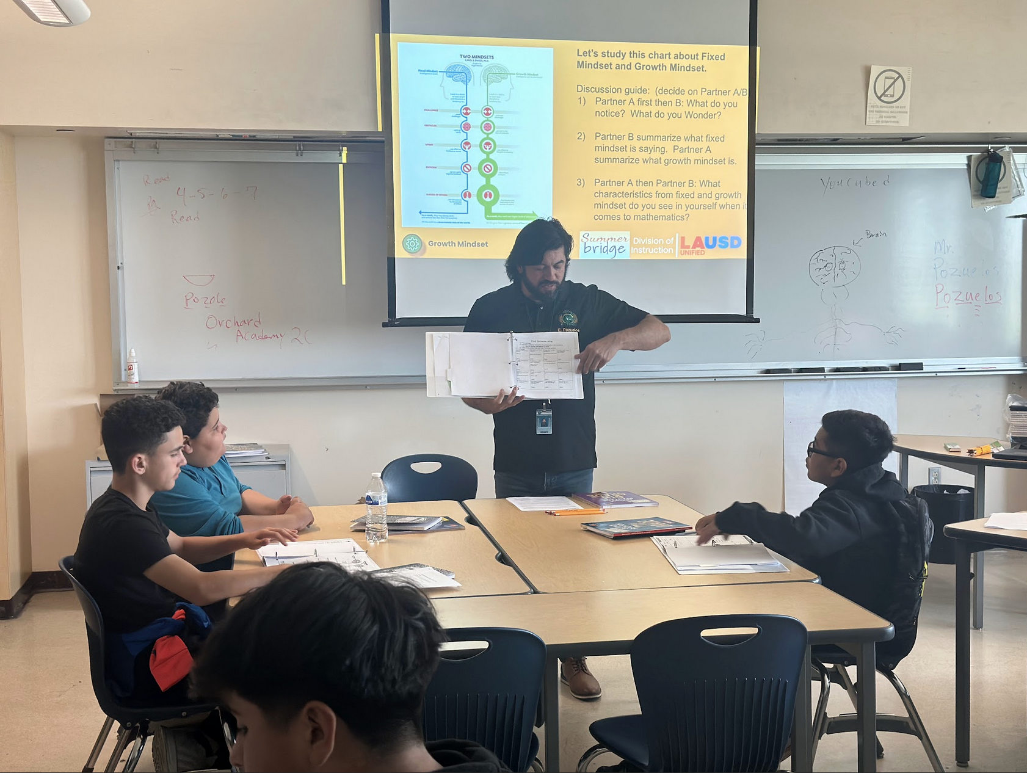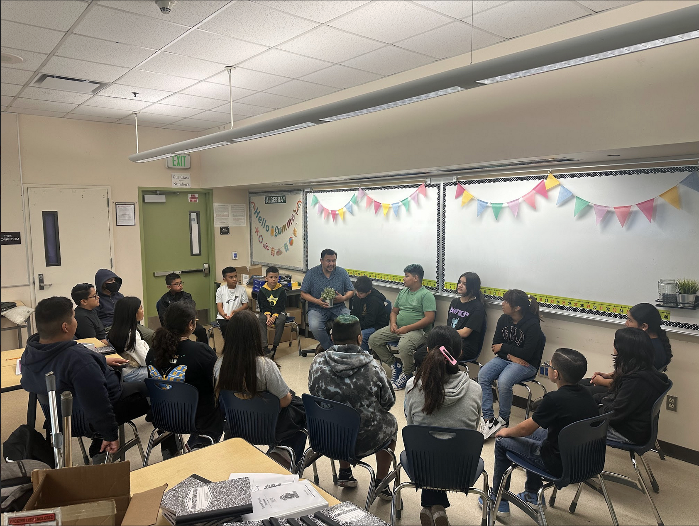

For more information, please contact Dr. Justin Lauer, Director of Middle School Instruction, jxl9505@lausd.net.

LINKED LEARNING SUMMER BRIDGE
Linked Learning middle and high schools are welcoming their students by introducing them to their career pathways and project-based learning. Over 2200 students across the District participate in Linked Learning summer bridge programs allowing 40 Linked Learning pathways to get to know their new classmates, teachers, and campus and provide an academic challenge before the school year starts. They are even supported by older students who have the role of mentors and are paid interns.
Carson High M.ED.IA. Magnet just concluded its Summer Bridge this past week, holding a showcase that featured student projects, awards, and prizes.

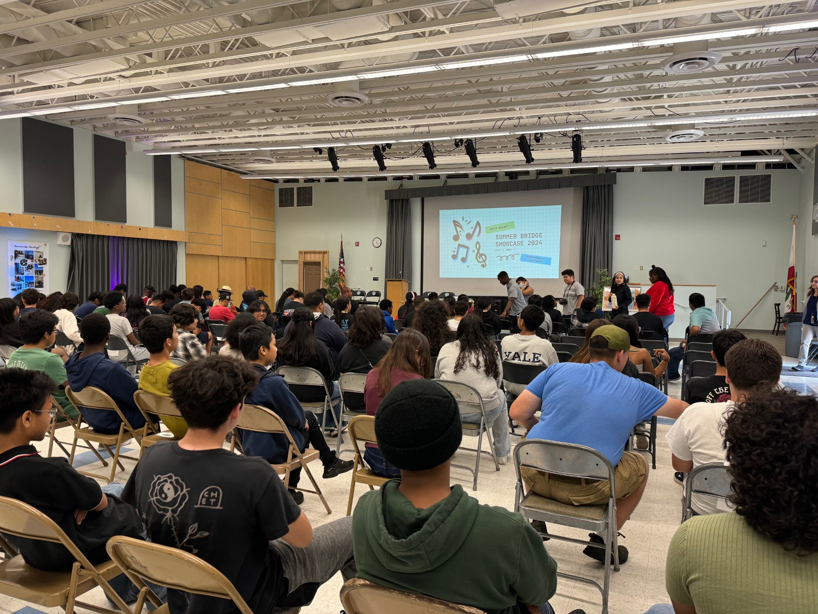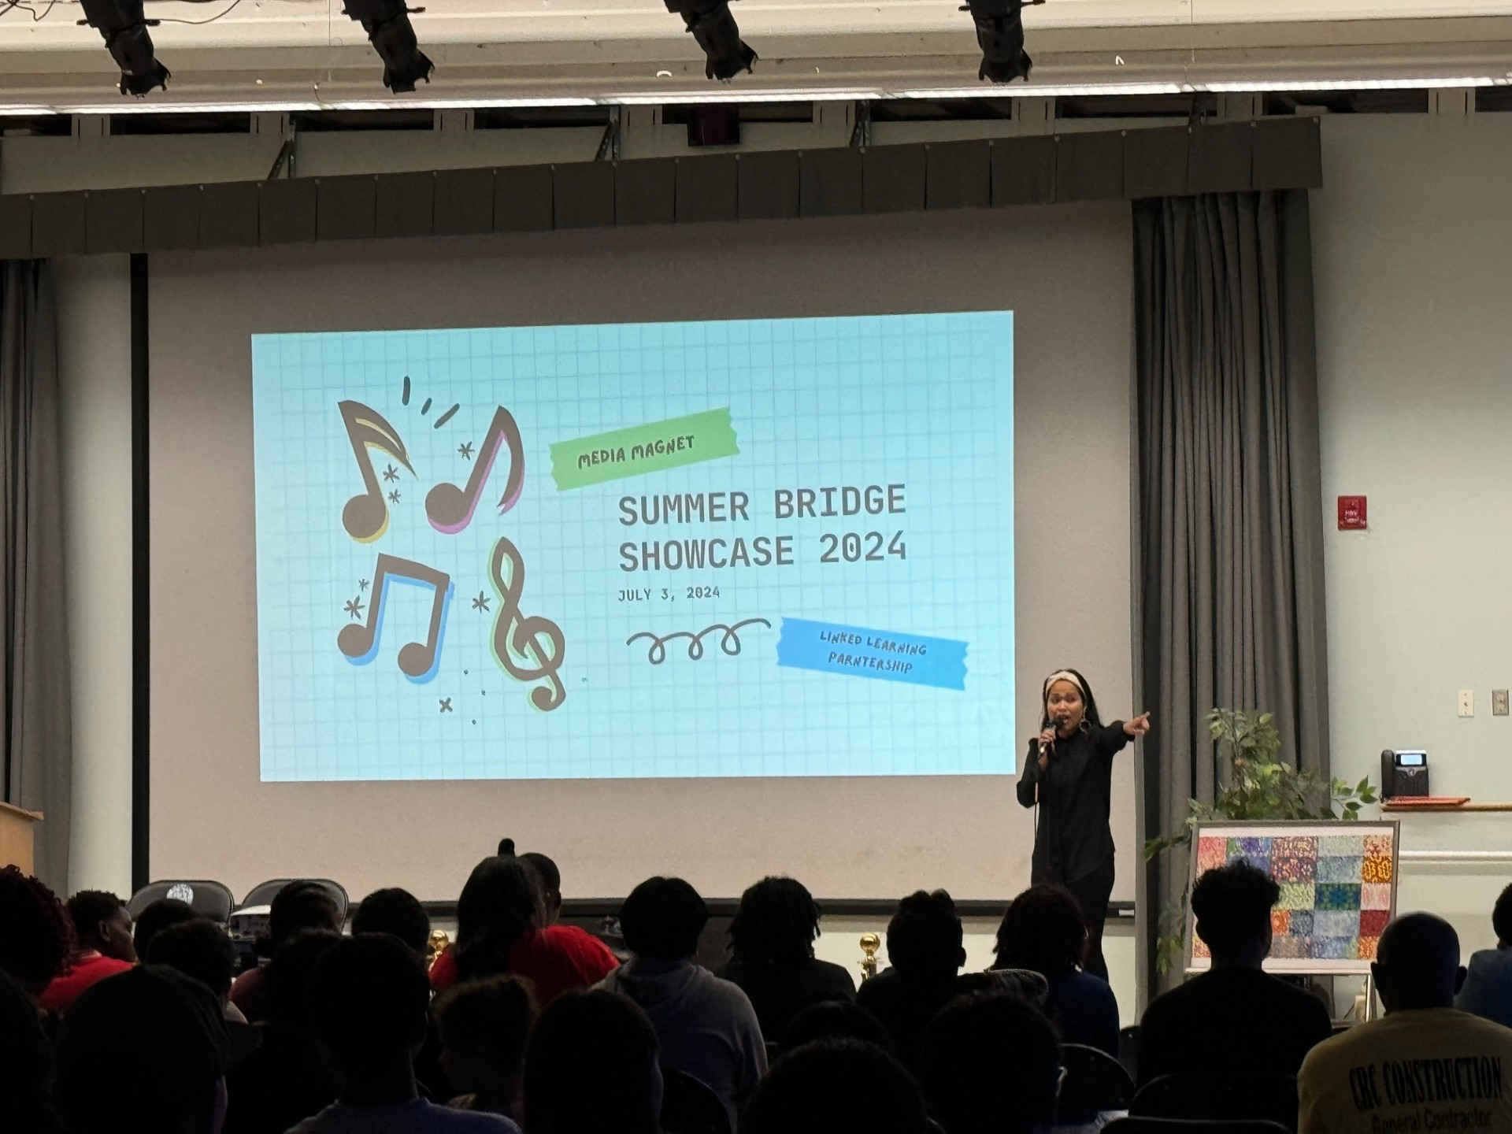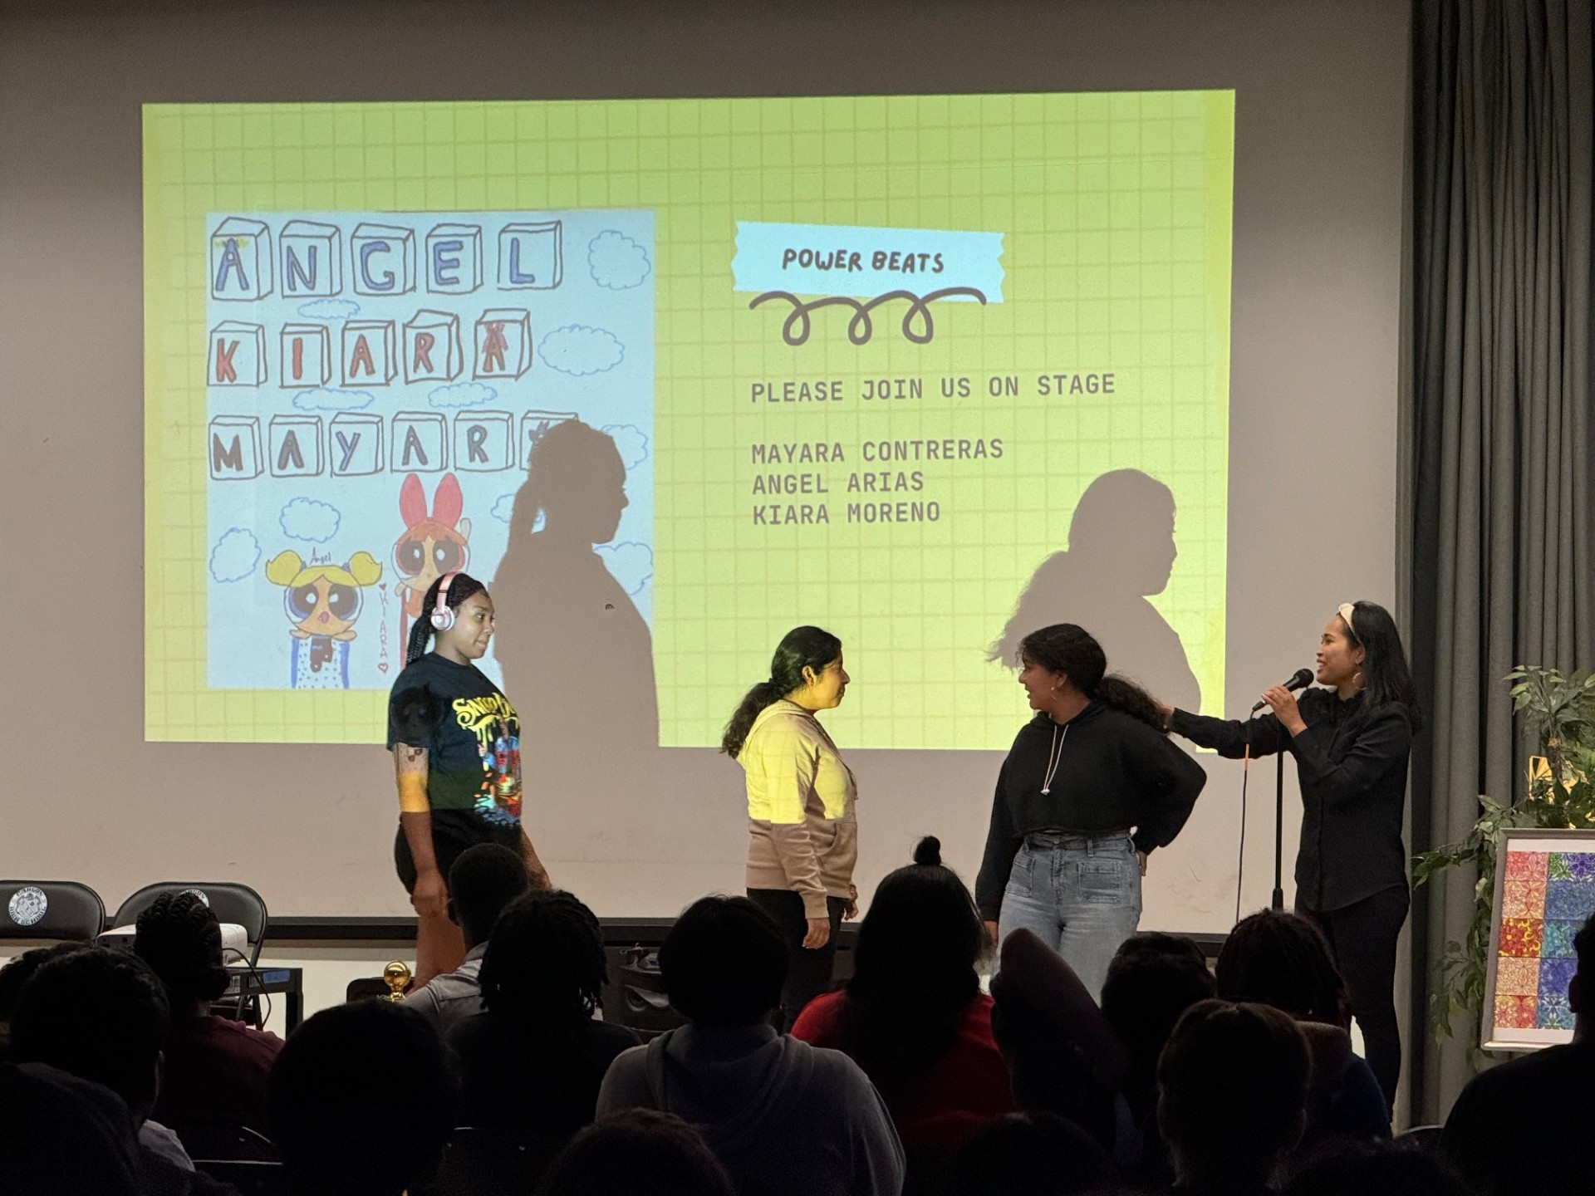

For more information, please contact Susan Canjurasusan.canjura@lausd.net

LAUSD STEAM Camp at the California Science Center
In the second week of the LAUSD STEAM Camp, held at the California Science Center, 114 third and fourth-grade students from Region South had the exciting opportunity to showcase their learning experiences. The camp, which emphasizes the integration of Science, Technology, Engineering, Arts, and Mathematics (STEAM), had a special visitor this week: Superintendent Carvalho.
During his visit, the students eagerly demonstrated their understanding of the "S" (Science) and "A" (Arts) components of STEAM. They explained to Superintendent Carvalho how the pH levels in dyes affect the colors produced in tie-dyed shirts. This hands-on activity highlighted the scientific principles behind pH levels and their impact on dye colors but also showcased creativity in creating unique tie-dye patterns.
The students' presentations were a testament to the engaging and educational experiences provided by the STEAM camp, illustrating the successful integration of interdisciplinary learning in a fun and practical manner.
- 299 unique student enrollment for STEAM Camp (as of 7/12/24)
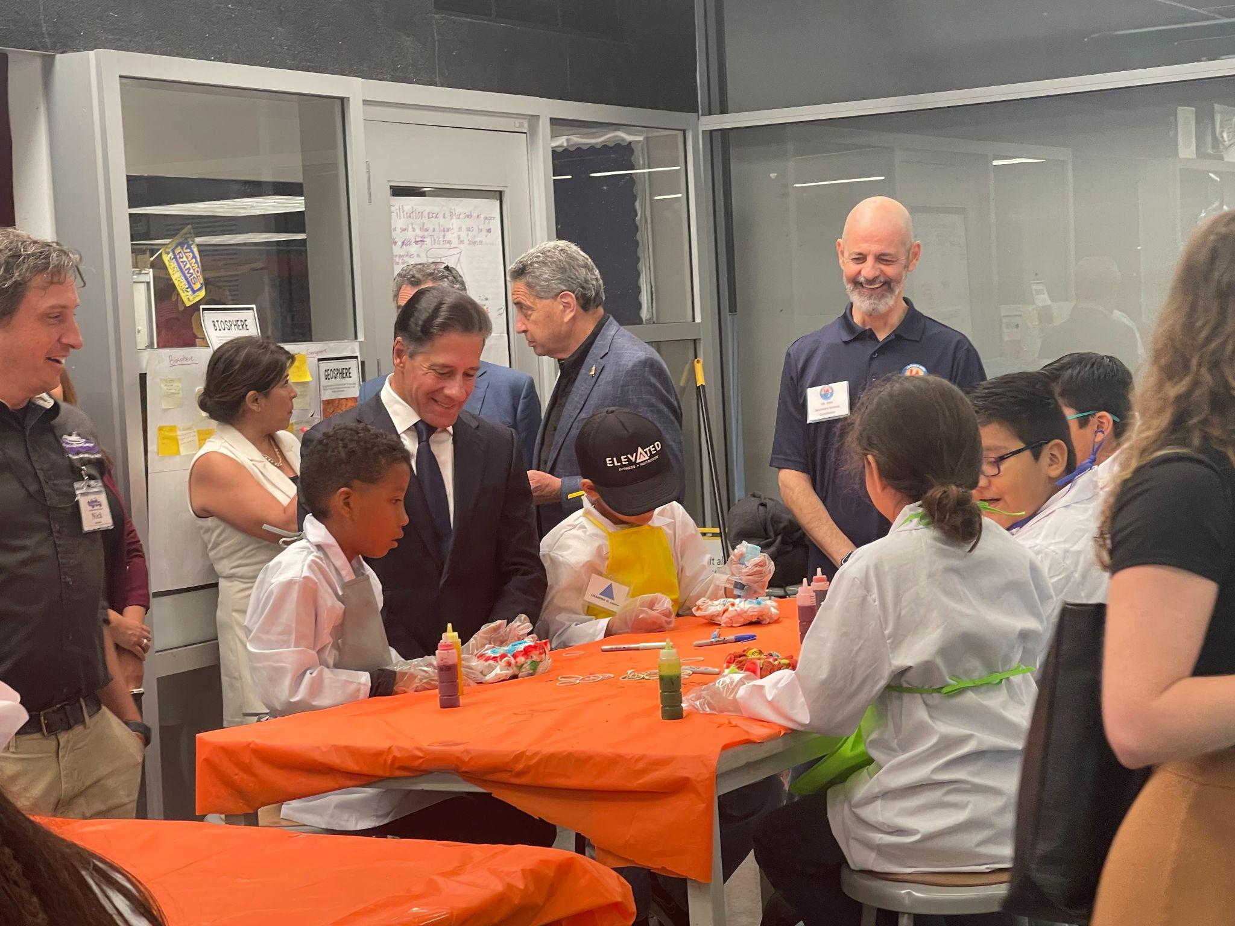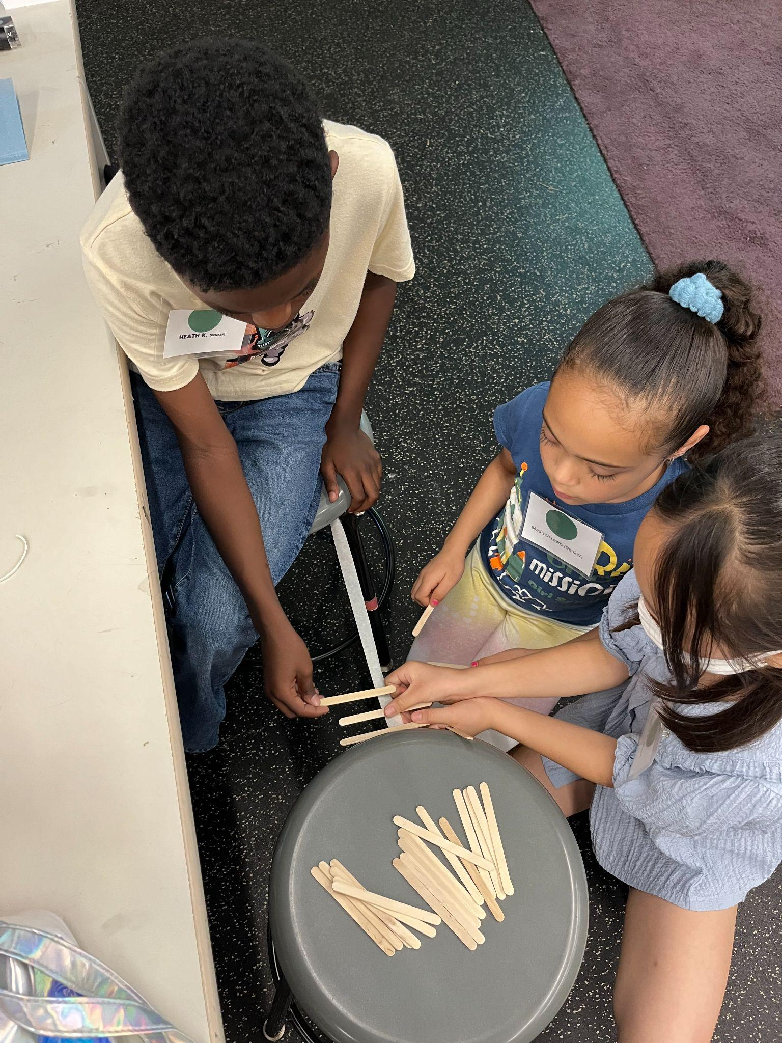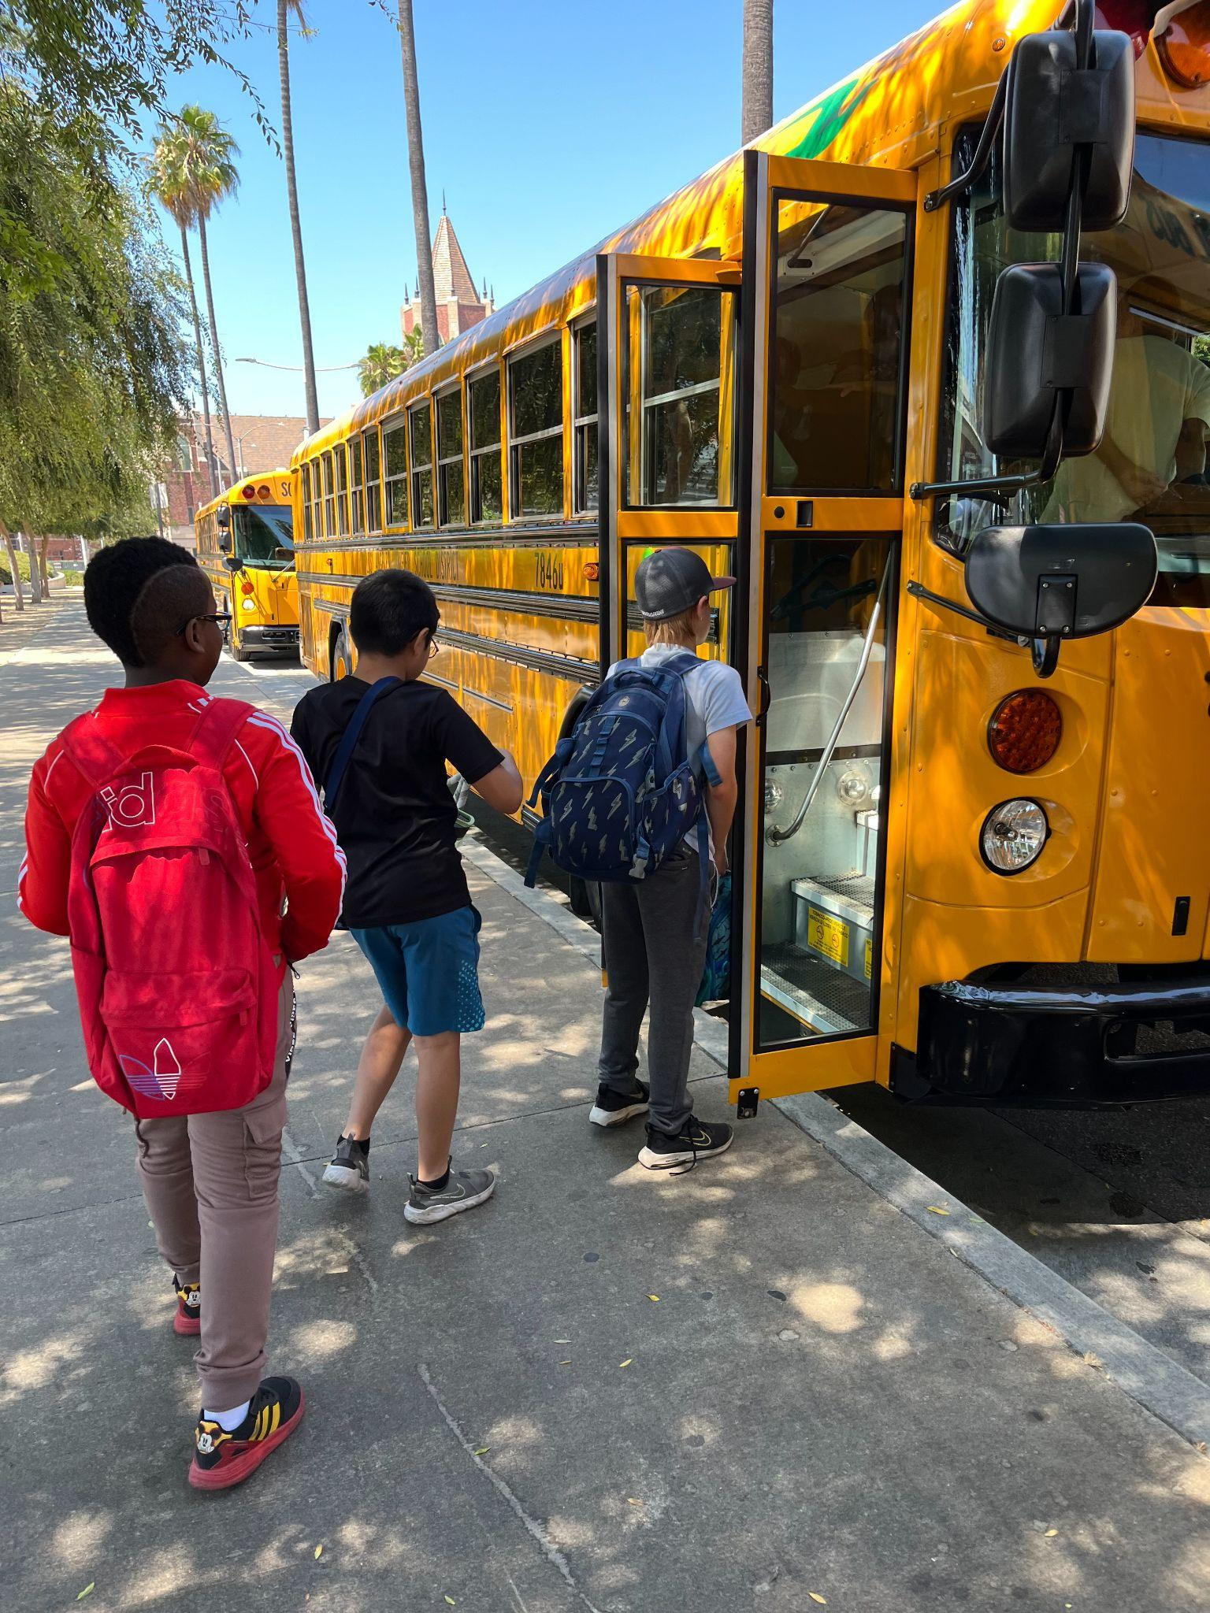
For more information, please contact Jaspreet Sandha, STEAM Coordinator, at jaspreet.sandha@lausd.net.

Extended School Year (ESY)
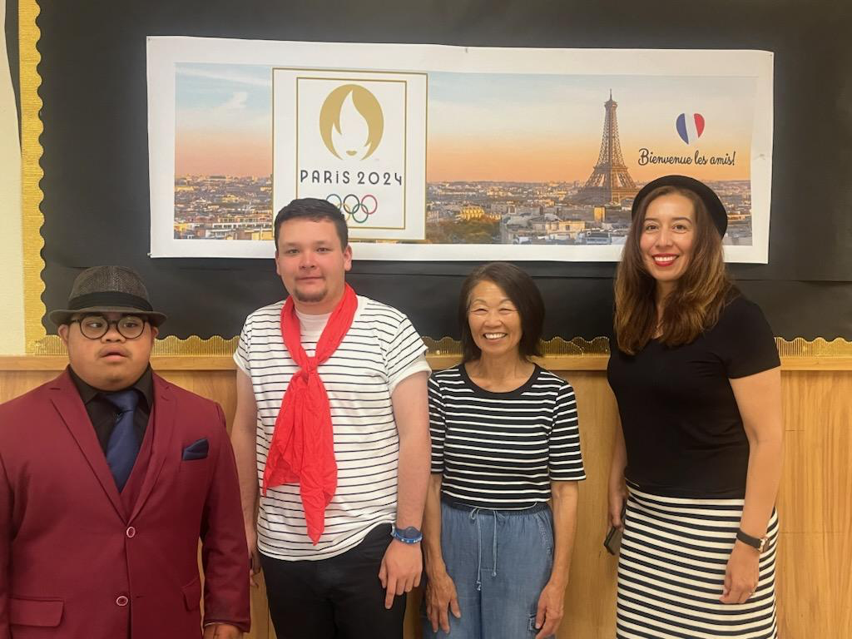
ESY is an IEP-determined service for students who require special education instruction or related services to prevent regression. Core ESY and ELOS use the same curriculum, including STEAM kits, PE, and Art enrichment materials.
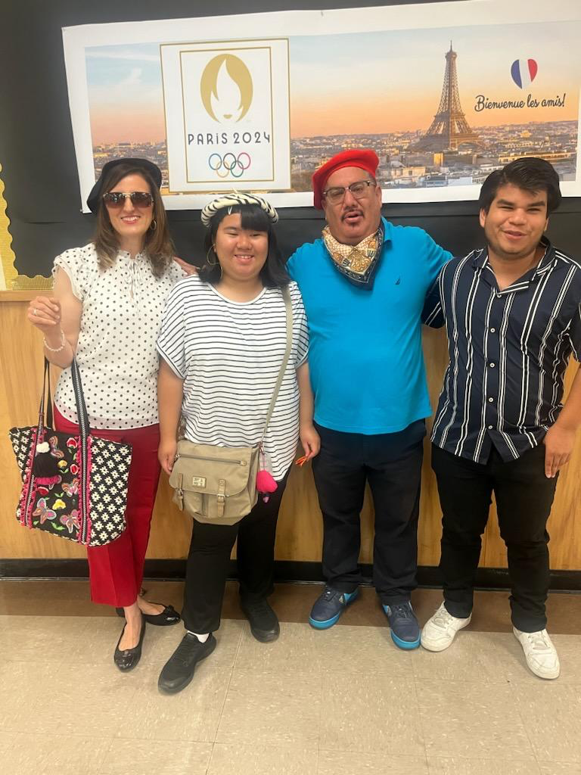
- 9,015 unique student enrollment for ESY (as of 7/12/24)
- Attendance = 8,730 as of 7/12/24
Students and staff at Willenberg Career and Transition Center celebrated the start of the Olympic season by dressing up in Parisian style!

Below: Students are hard at work on academic skill practice at 99th Street Elementary School.
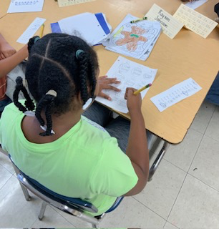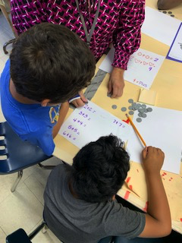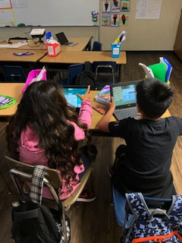
For more information, please contact the Division of Special Education, at esy@lausd.net or (213) 241-6701.

BEYOND THE BELL PROGRAMS (BTB)

EXPANDED LEARNING PROGRAM
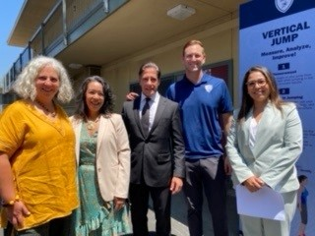
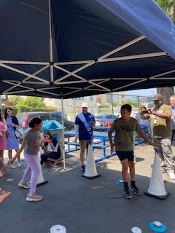
Beyond the Bell provides expanded learning programs for students in grades TK-12 at selected school sites for summer enrichment opportunities that provide academic engagement, physical activities, creative activities, and social-emotional learning.

A press conference and site visit to Monte Vista ES LA’s BEST program celebrating the Summer of Joy with Superintendent Carvalho, Dr. Estrada, Dr. Baez, Daren Heaton of Science of Sport, and Dr. Ana Ponce of GPSN.
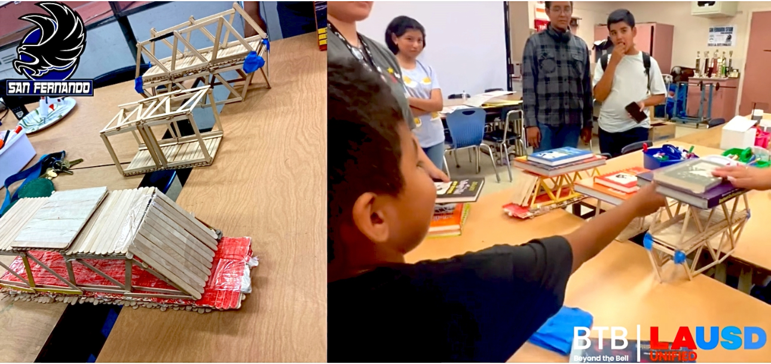

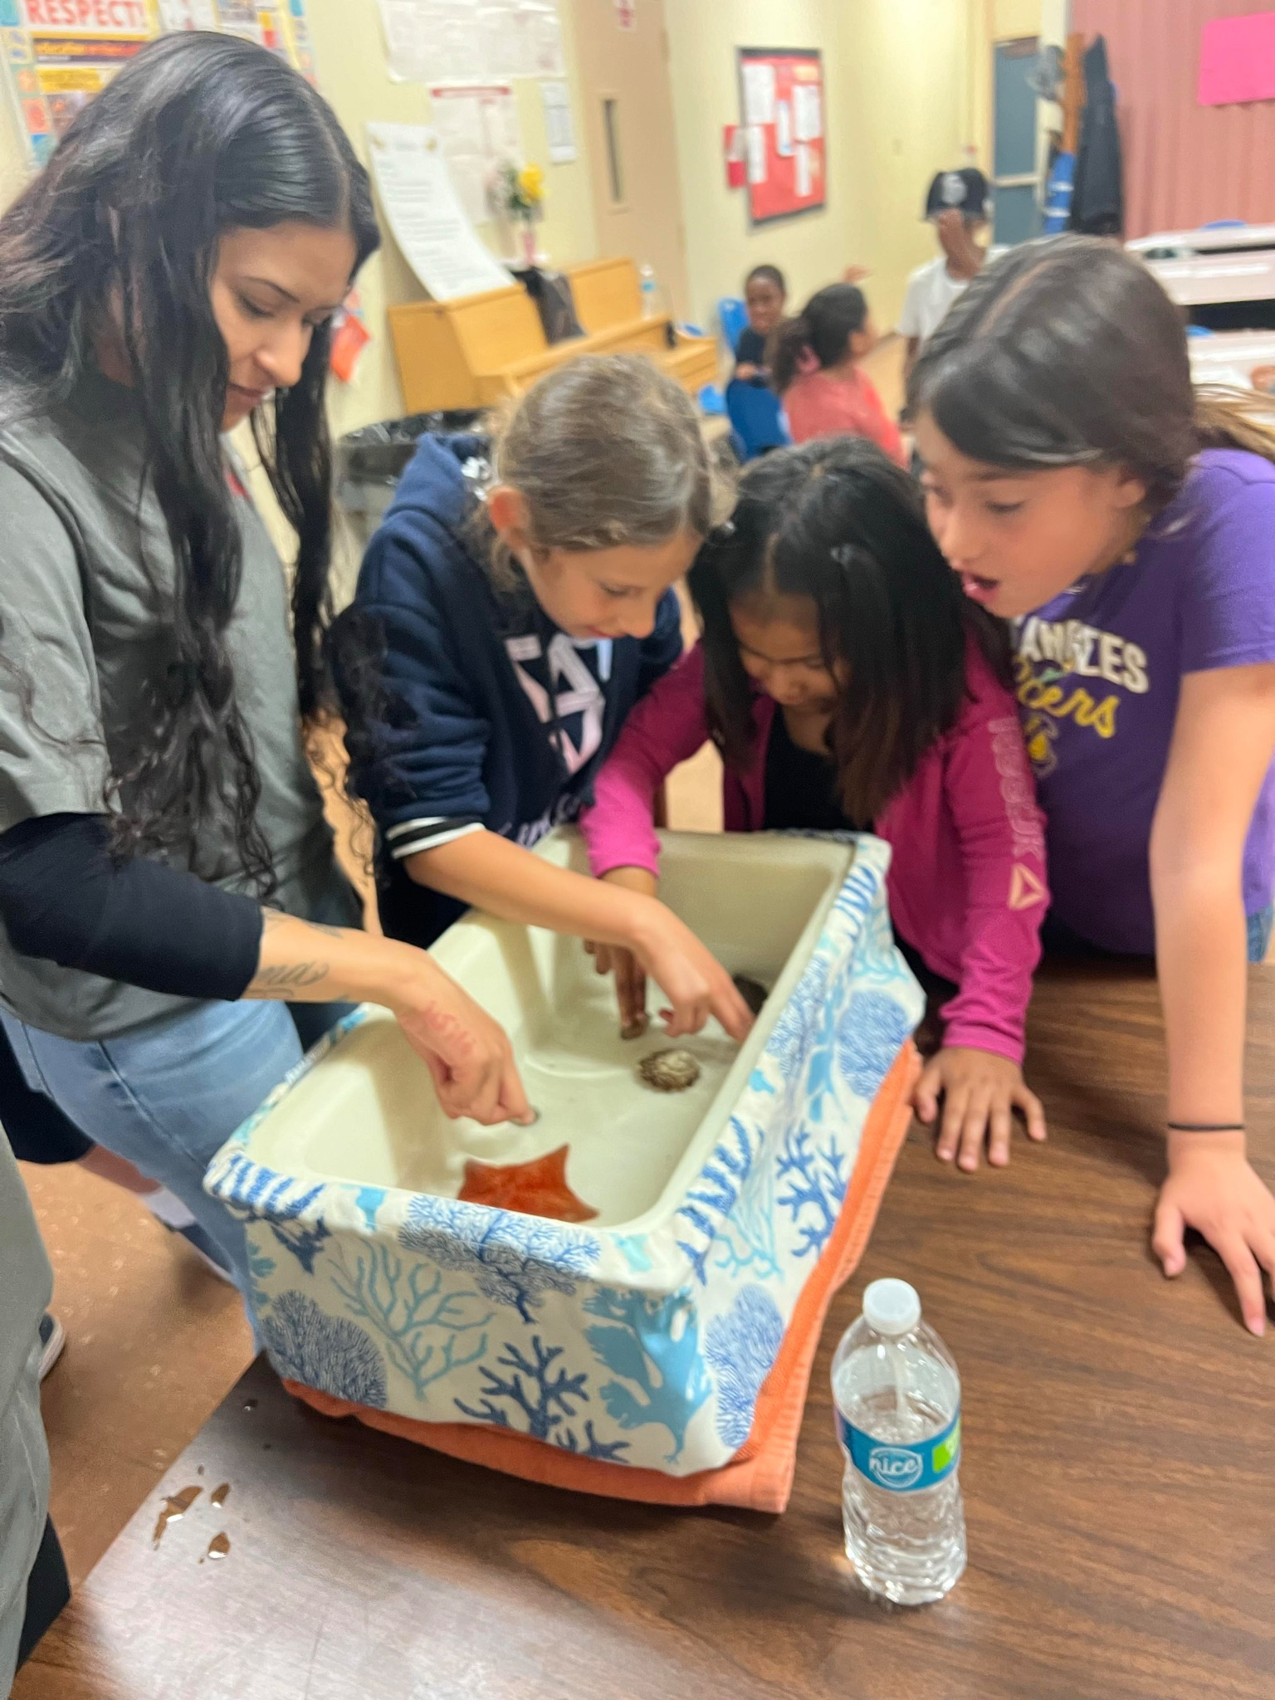
San Fernando Middle School Summer Camp Program STEAM bridge building project

Students participating in a hands-on activity presented by the Roadhouse
Aquarium at 59th St Elementary.
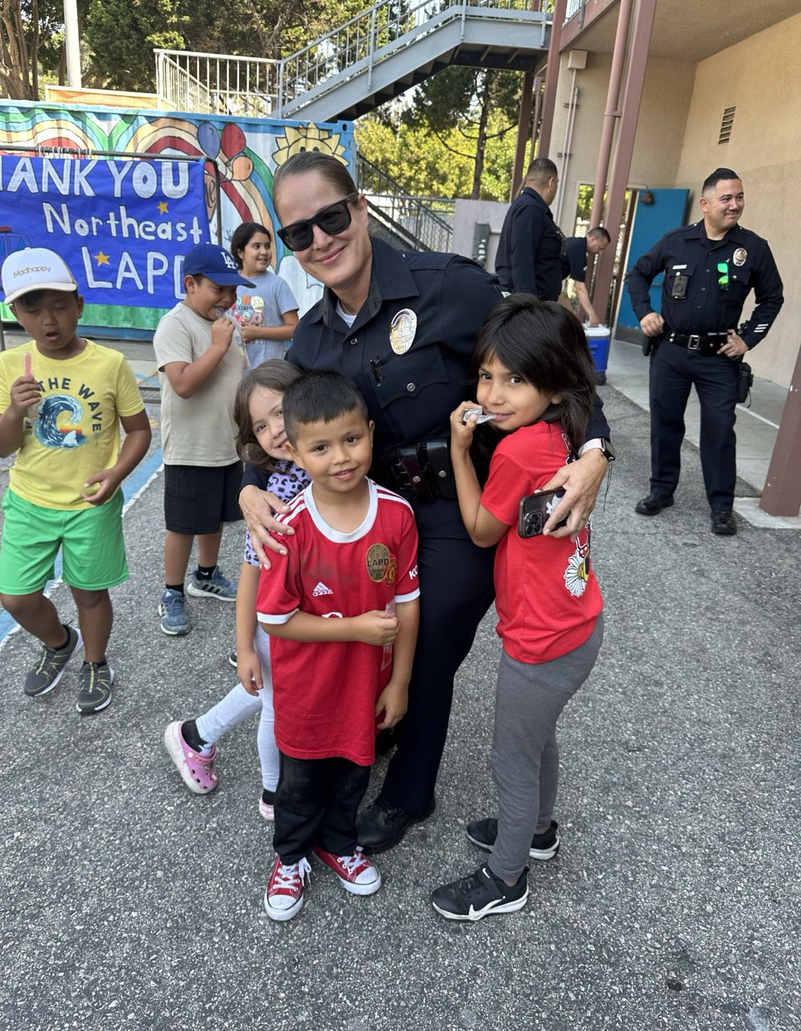
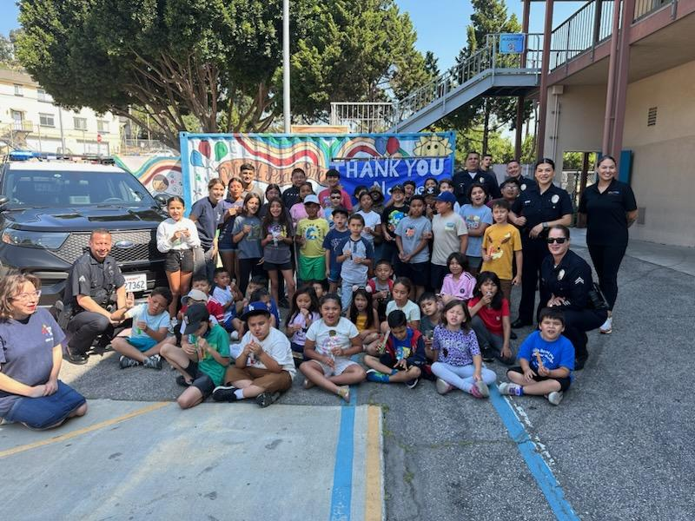

The Northeast LAPD Division visited Allesandro Elementary. They spoke to the students about safety, careers in law enforcement, how they serve the community, showed the kids some of their equipment, and had their helicopter fly overhead and give the kids a shout-out through the helicopter's loudspeaker.

- Attendance/Students Served - 19,912
- For more information, please contact Debe Loxton at debe.loxton@lausd.net

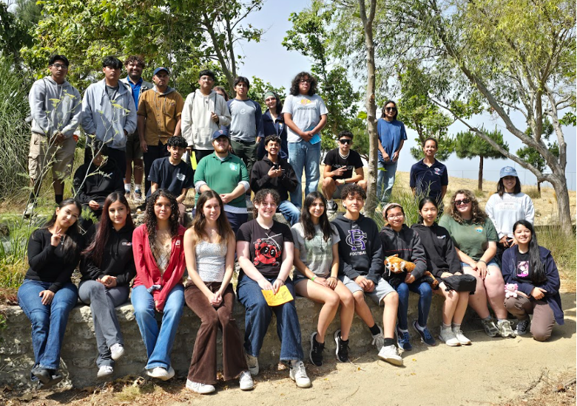
Outdoor Education Camps

High School students take a break during an ocean view hike at Point Fermin Outdoor Education Center. A visit to the USS Iowa, sailing a Tall Ship, and afternoons at the beach were all part of the experience.

- Attendance: 2,101
- For more information, please contact Ana Estevez at ana.estevez@lausd.net

INTERNATIONAL NEWCOMER ENRICHMENT PROGRAM (INEP)
On June 2nd-3rd, International Newcomer Enrichment Program (INEP) students visited the Getty Center Museum. Teachers engaged students in a self-guided tour of the current Getty Center exhibits including The Book of Marvels: Wonder and Fear in the Middle Ages, where students were awed at the vibrant, gilded illustrations in medieval manuscripts and the work of Camille Claudel, where students explored her sculptures along with photos of the artist at work. Students rounded off their day with a sack lunch at the Garden Terrace Cafe Area and a quick tour of the Central Garden.
Students took notes, drew renditions of the artwork, and snapped photos in preparation for having constructive conversations with their peers based on the artwork and their experience at the Getty Center.
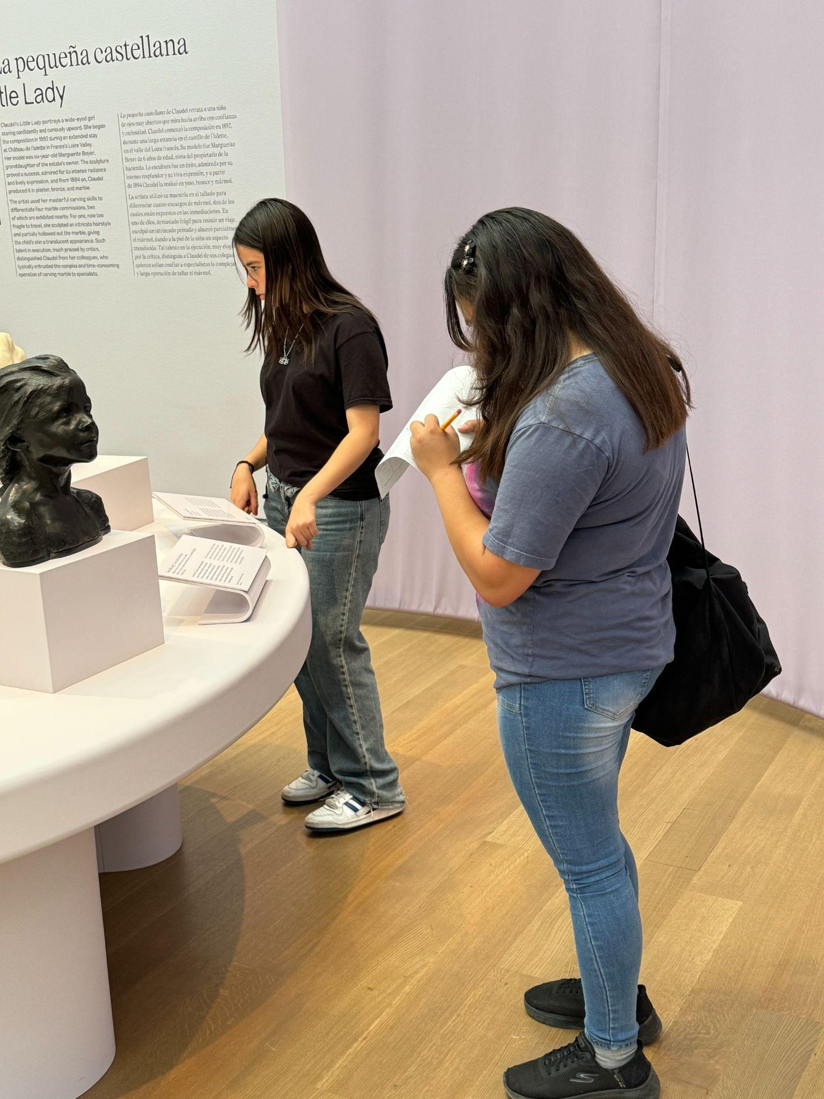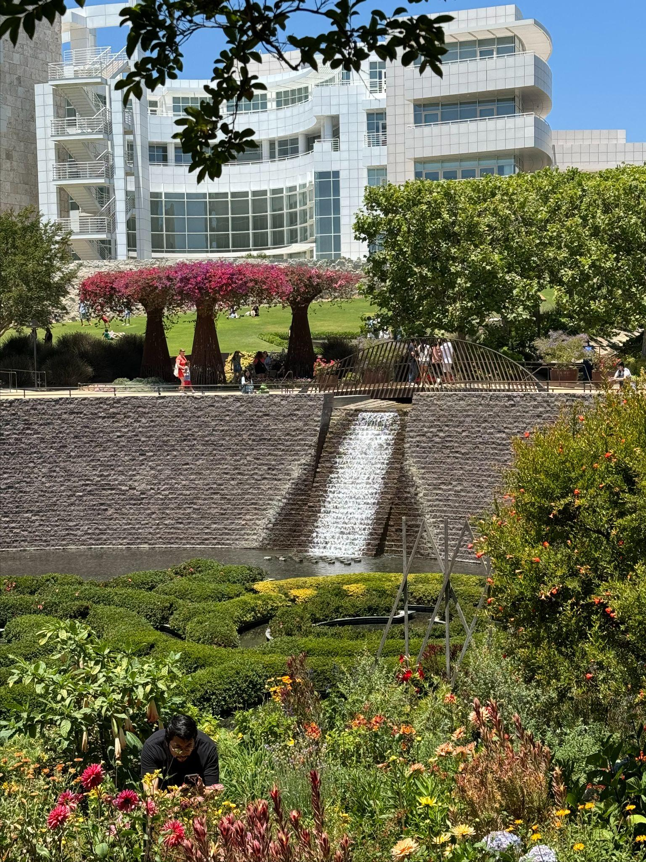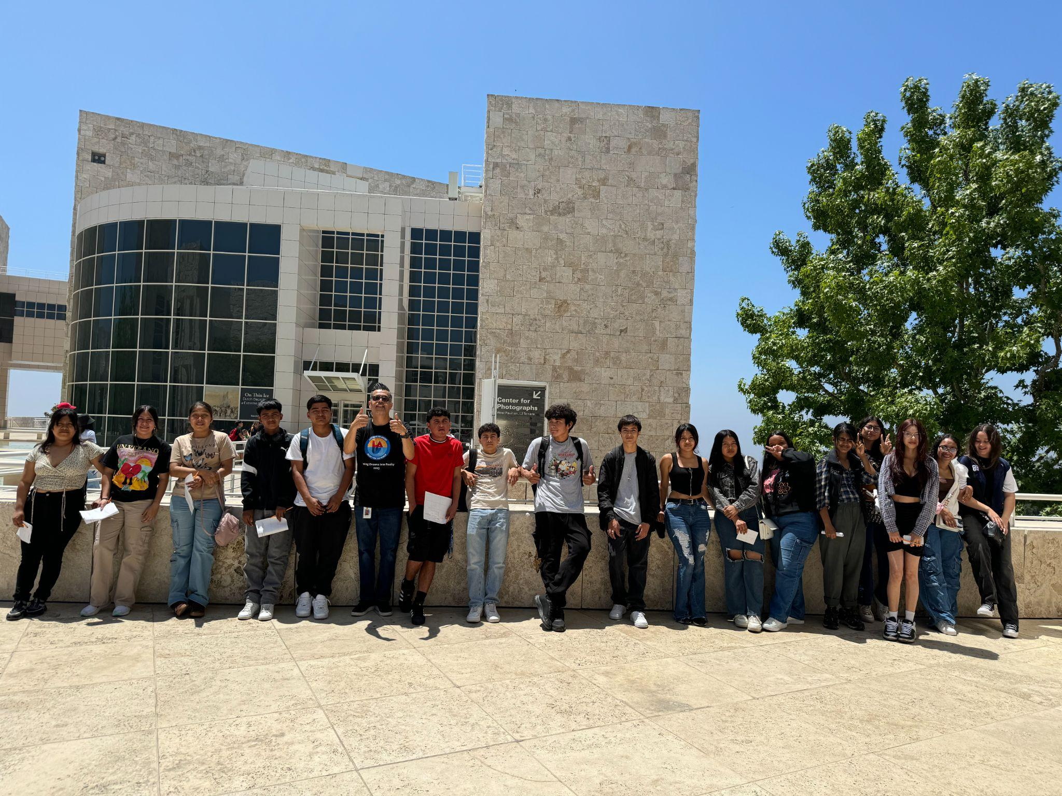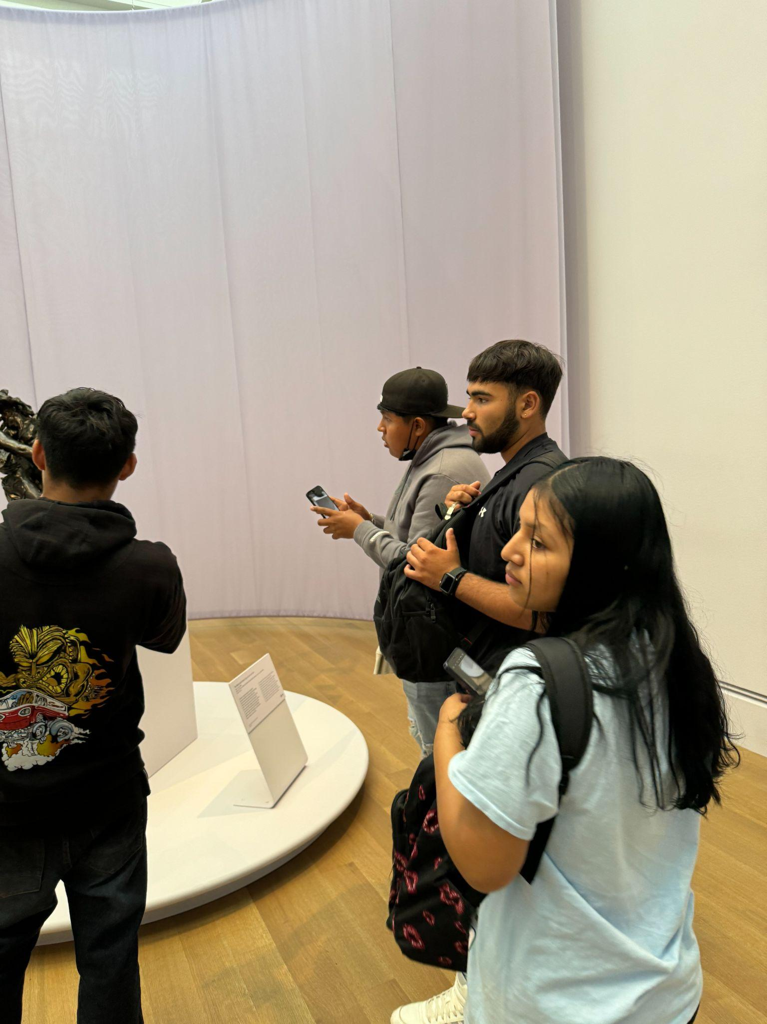

- 1,061 unique student enrollment for the Newcomer Program (as of 7/12/24)

For more information, please contact Bernie Carrasco at bcarrasc@lausd.net.

SENIOR HIGH LOCAL DESIGN ENRICHMENT
Twenty Senior High Schools across the District were offered exciting and innovative in-person enrichment classes. These courses expand on students’ career interests and college pursuits. The courses ranged from Computer Programming, American History of Rock and Roll, Honors Math Principles, Forensics, and Design. This week we highlight:

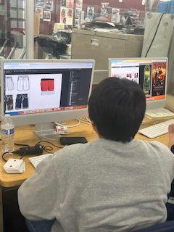
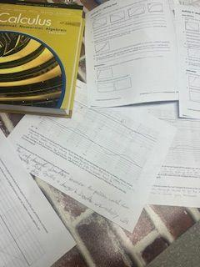
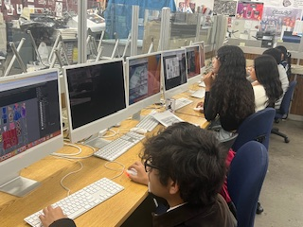
Honors Math Principles at Sylmar Charter HS and Design at Garfield HS
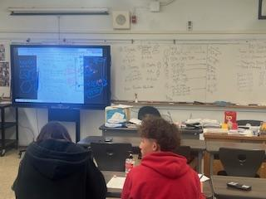

- For more information please contact your high school or Adriana Trejo, High School Director, at adriana.trejo@lausd.net

MIGRANT EDUCATION @ victor.gonzalez@lausd.net
- 124 unique student enrollment for Migrant Education In Person (as of 7/12/24)
- 23 unique student enrollment for Migrant Education Online (as of 7/12/24)

For more information, please contact victor.gonzalez@lausd.net or follow us on Instagram and Facebook.
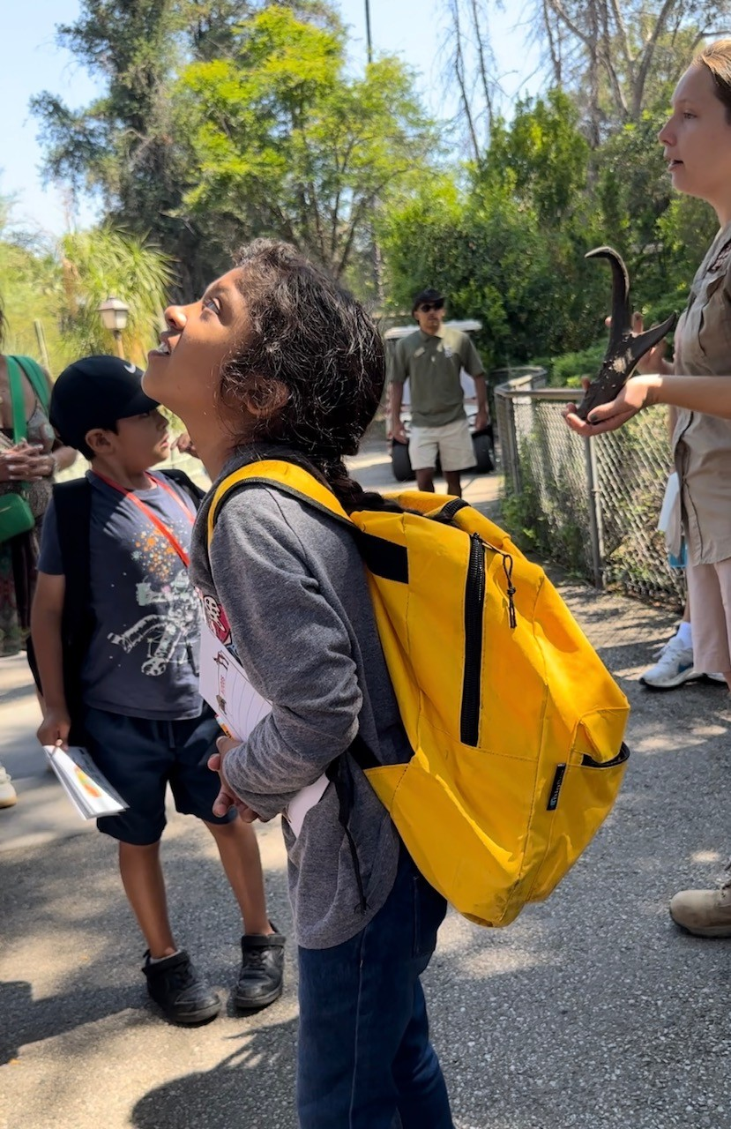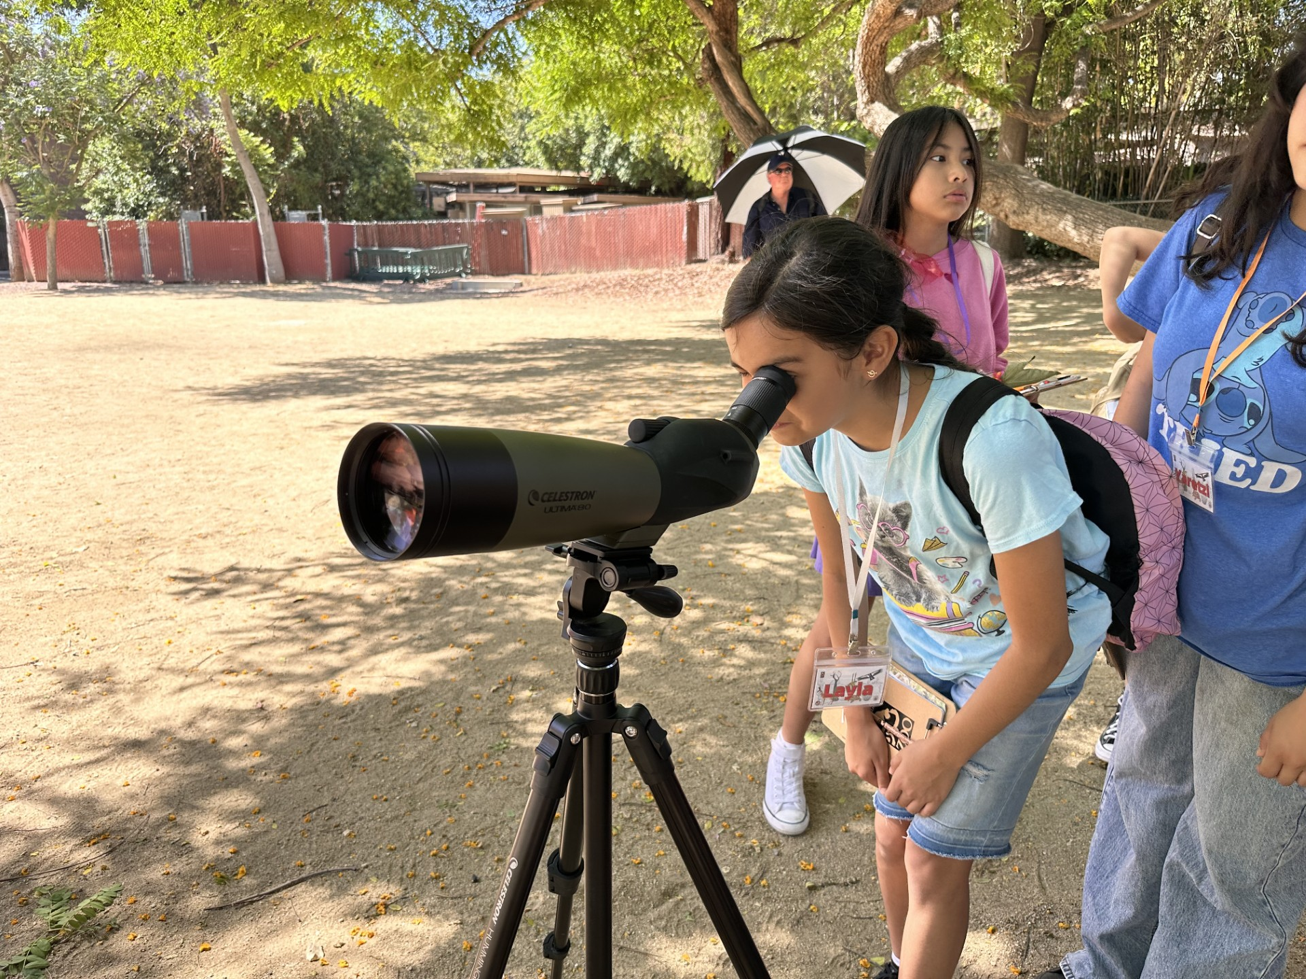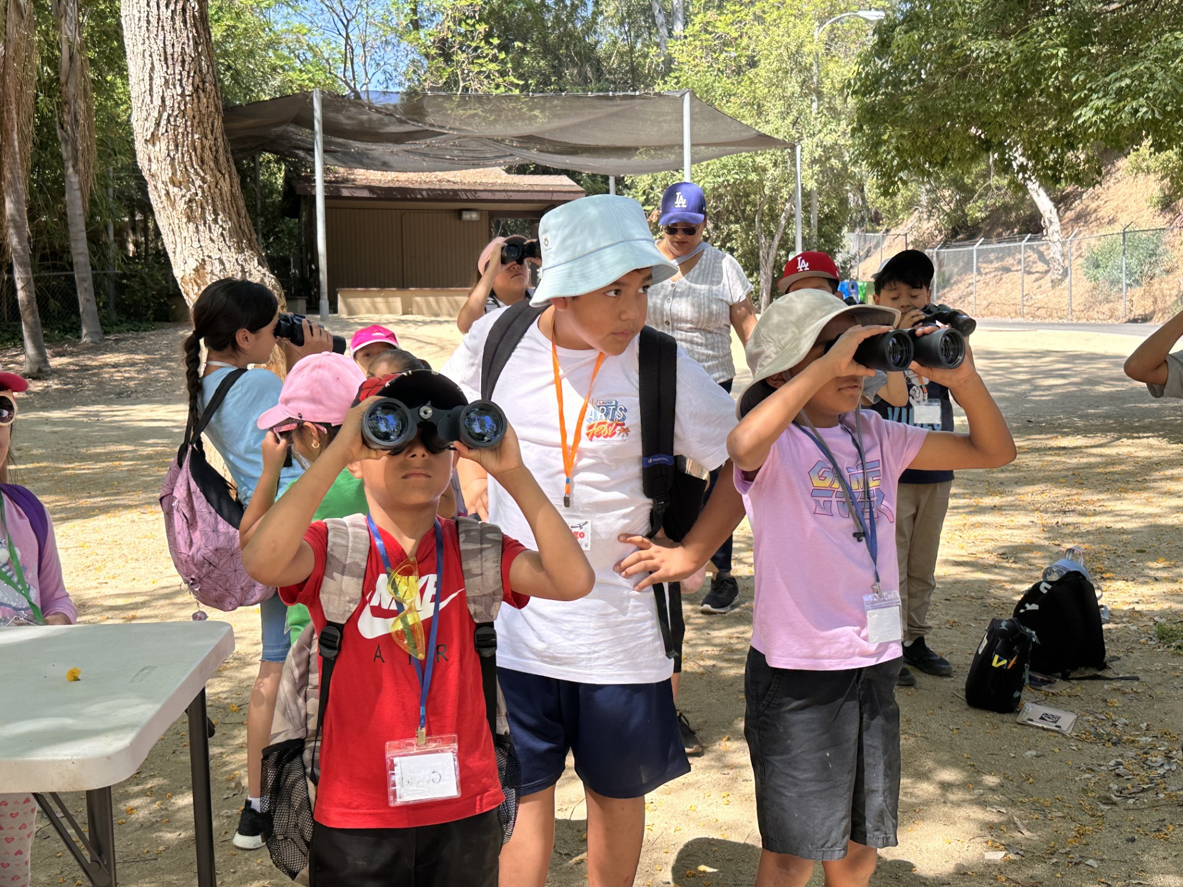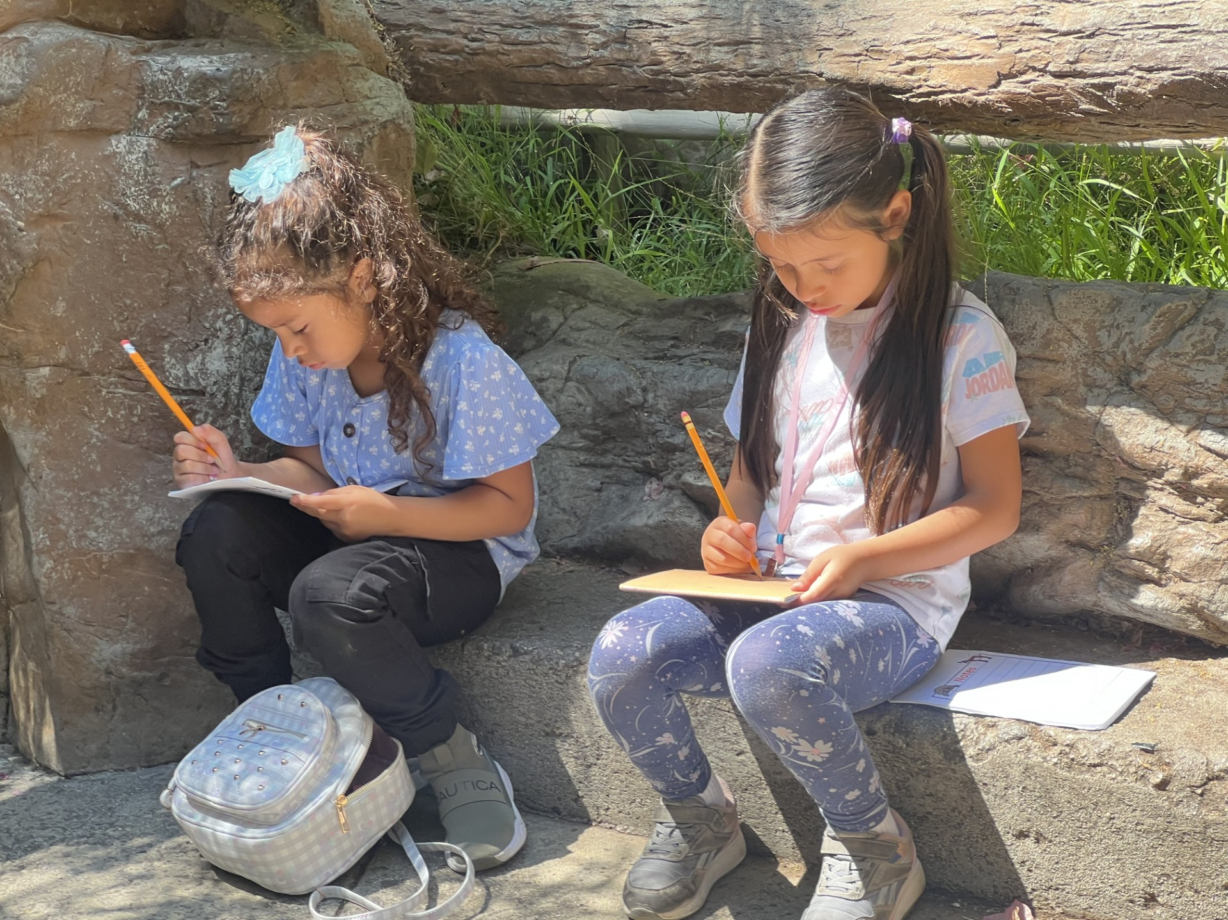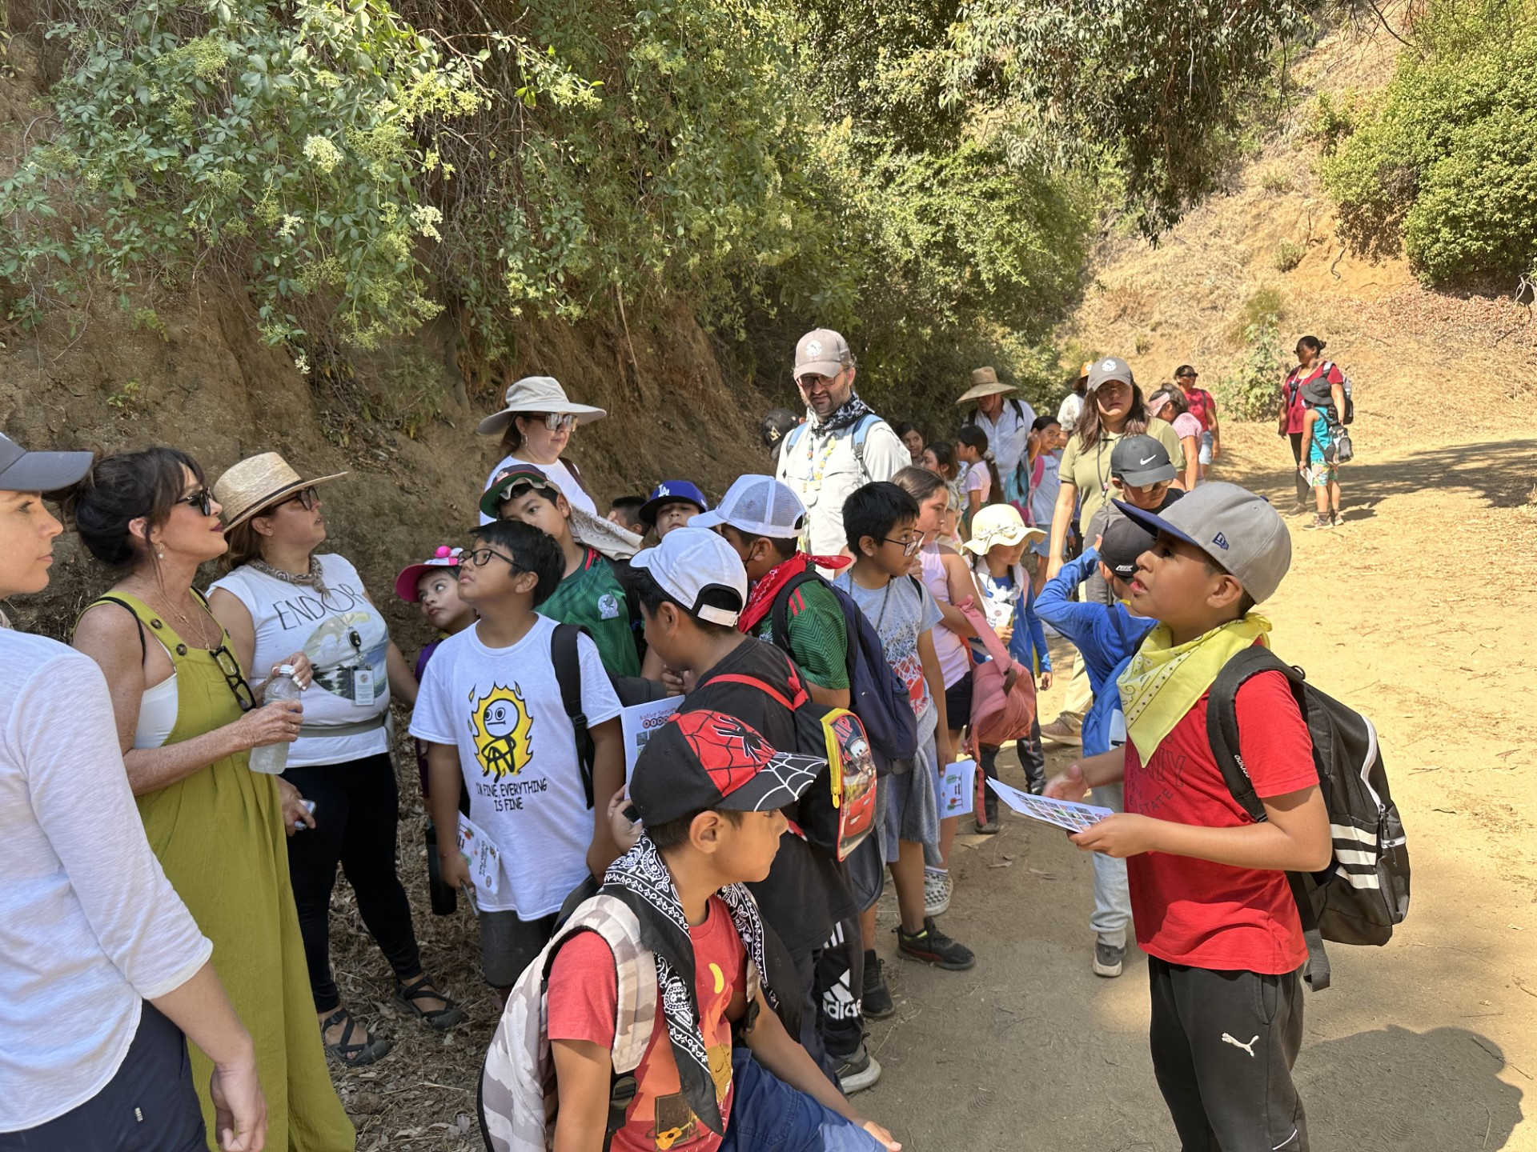

MEP is working together with the Los Angeles Zoo for Summer School 2024!
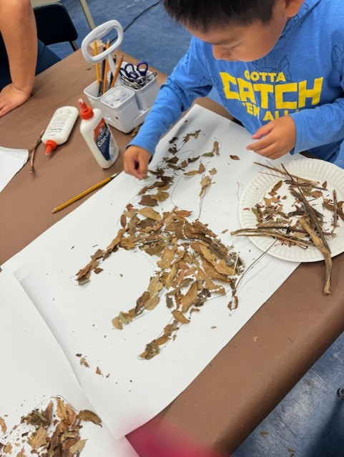
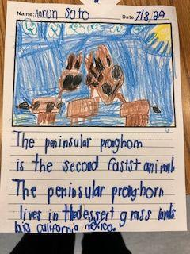
The MEP Summer School Program and the Los Angeles Zoo are working together this summer to provide exceptional learning experiences for our amazing MEP students by delivering distinctive and diverse learning opportunities and creating a positive learning environment! Our students get first-hand instructions from zoo educators, zoo curators, and zoo keepers that are not offered to the general public.
Our first graders are learning about the endangered Peninsular Pronghorns at the zoo and we are doing research in the computer lab at school. The students will utilize the learning they receive at the zoo and on campus to showcase their learning with written articles, art displays, and oral presentations to the public at the LA Zoo. Come check out the amazing MEP Program students at the Los Angeles Zoo this Summer!
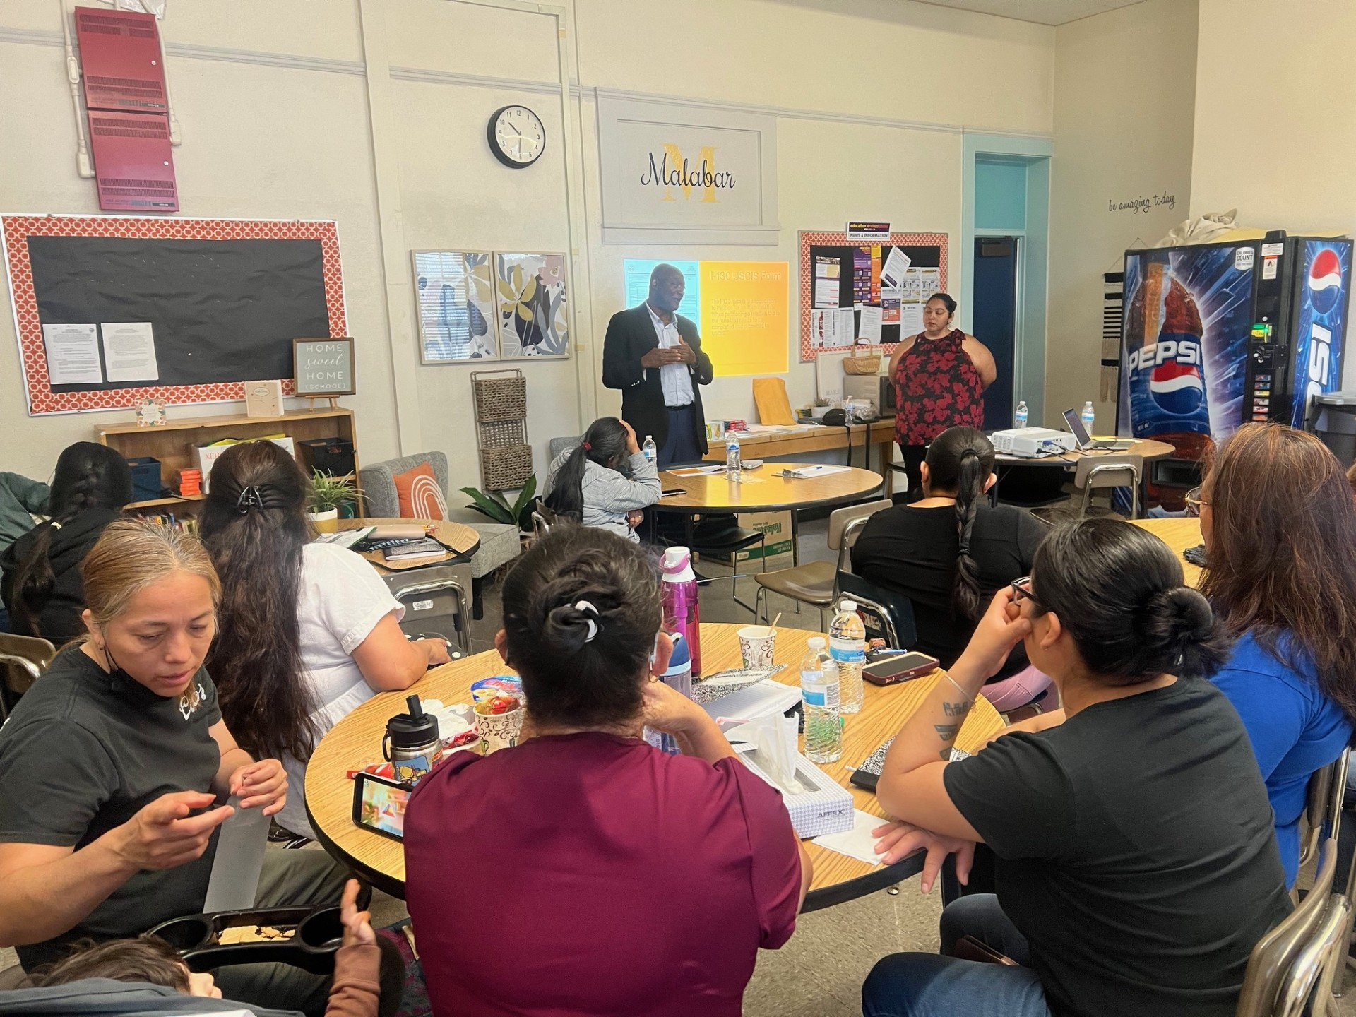
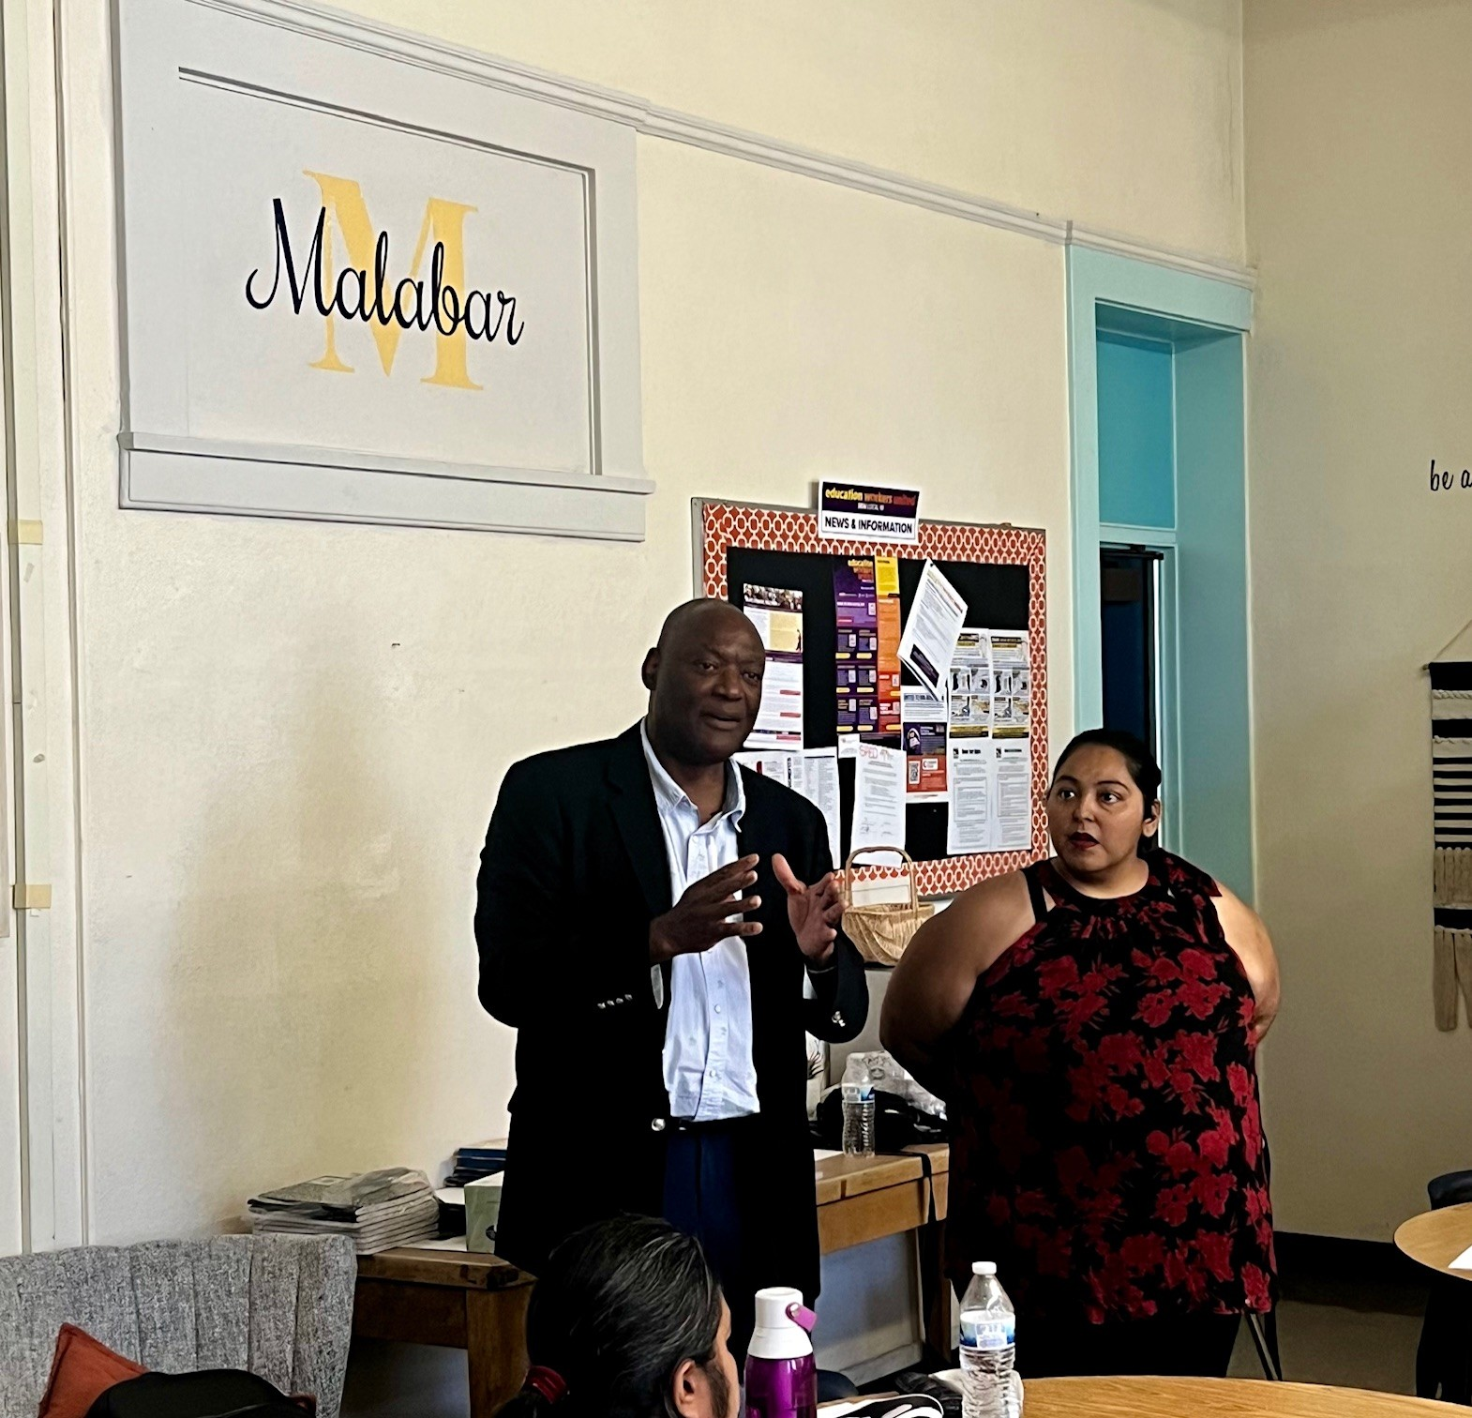
Parent Workshop
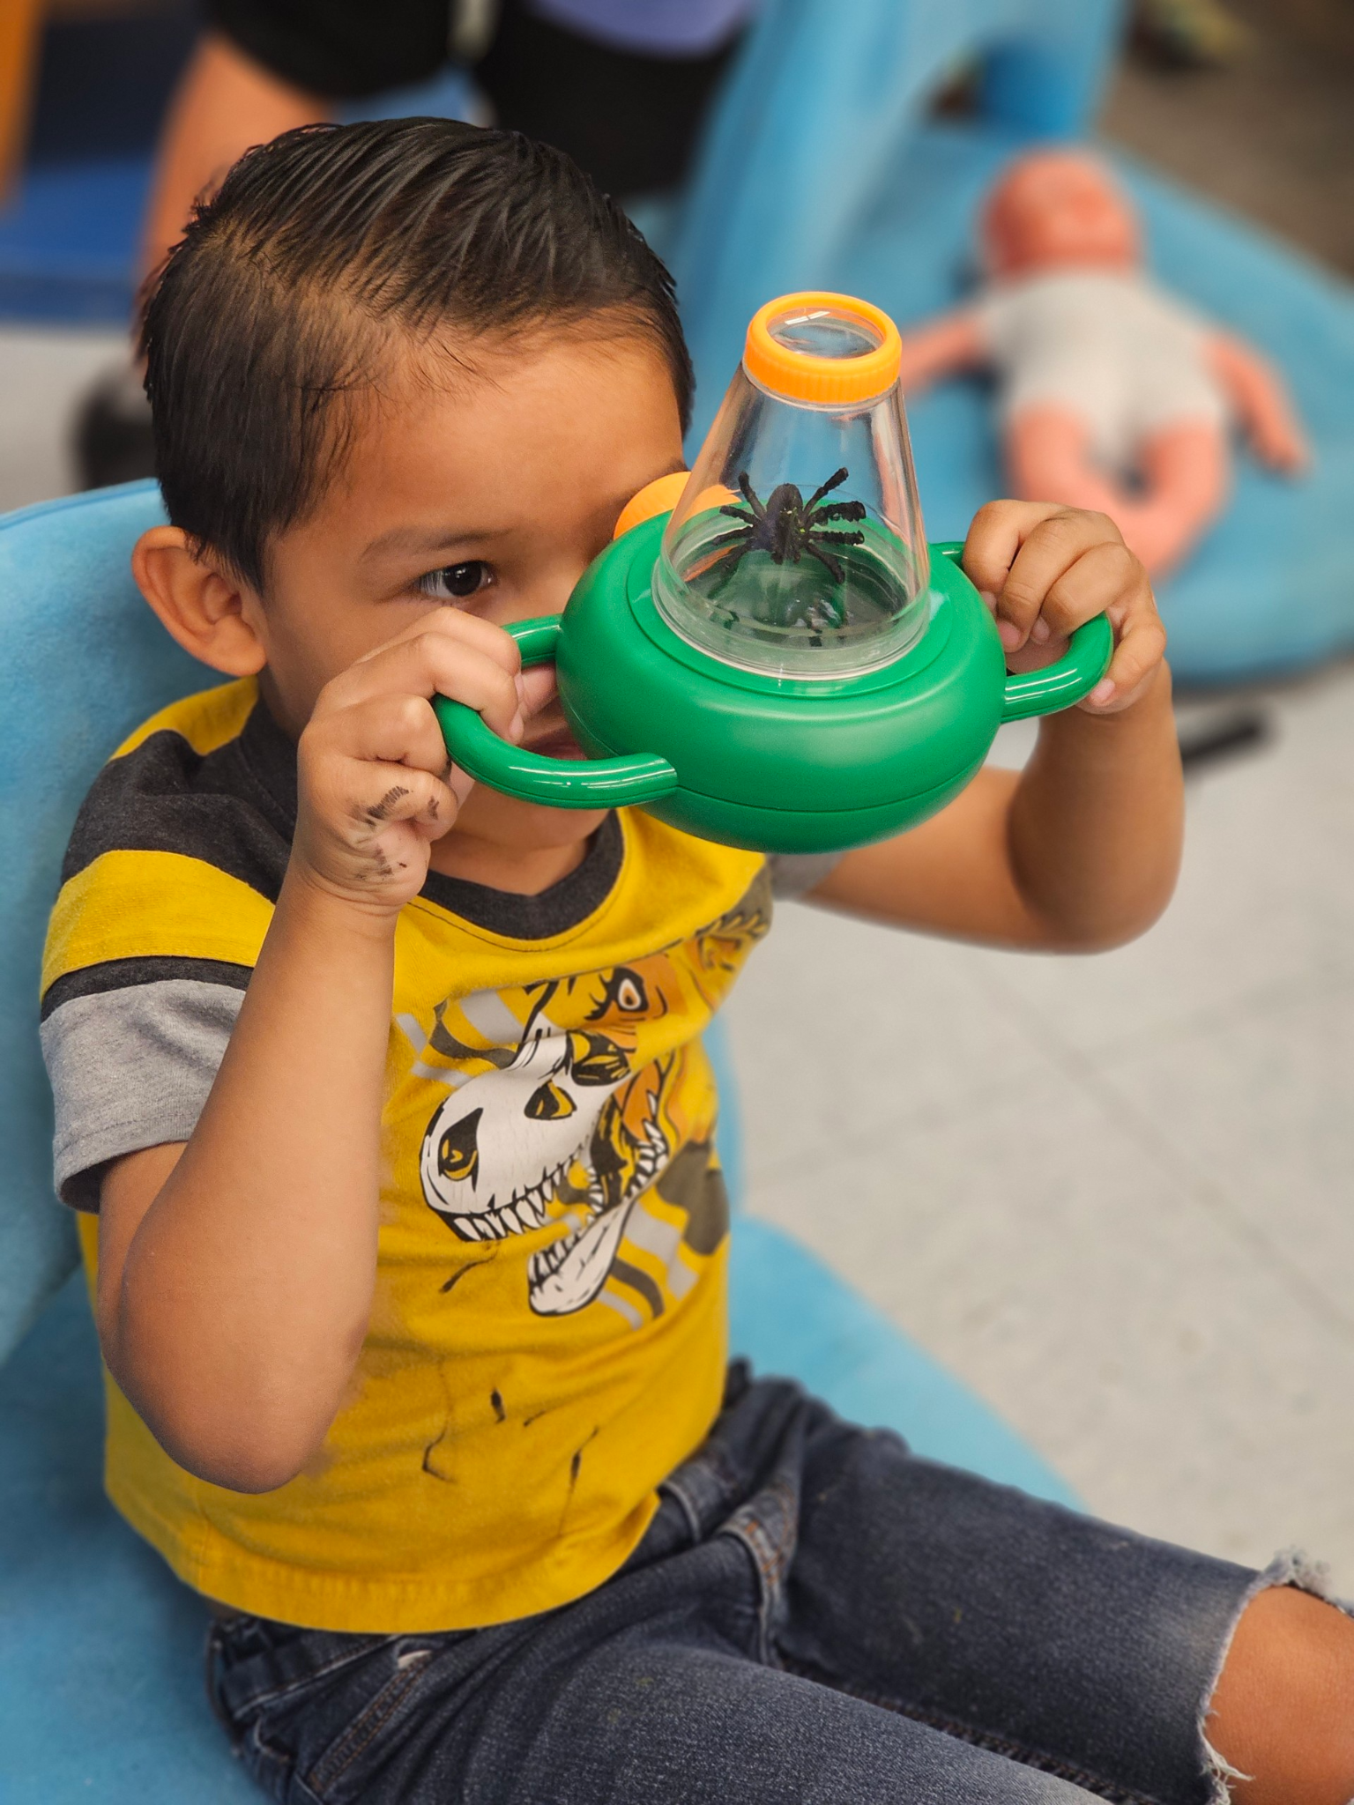
Attorney Edwin Aimufua, sponsored by the African Coalition, provided an immigration clinic with a parent question-and-answer session. Parents asked about various avenues to achieve legal status for themselves and loved ones.

School Readiness
This summer, our preschoolers are embarking on an exciting journey into the world of insects! Through hands-on activities and interactive lessons, students discover the diversity and importance of these fascinating creatures. From observing butterflies up close to learning about the life cycles of ants, our little explorers are gaining valuable knowledge about insect habitats, behaviors, and their roles in nature. This engaging curriculum sparks the students’ curiosity and fosters a deeper appreciation for the natural world around us. Stay tuned for more updates on their insect adventures!

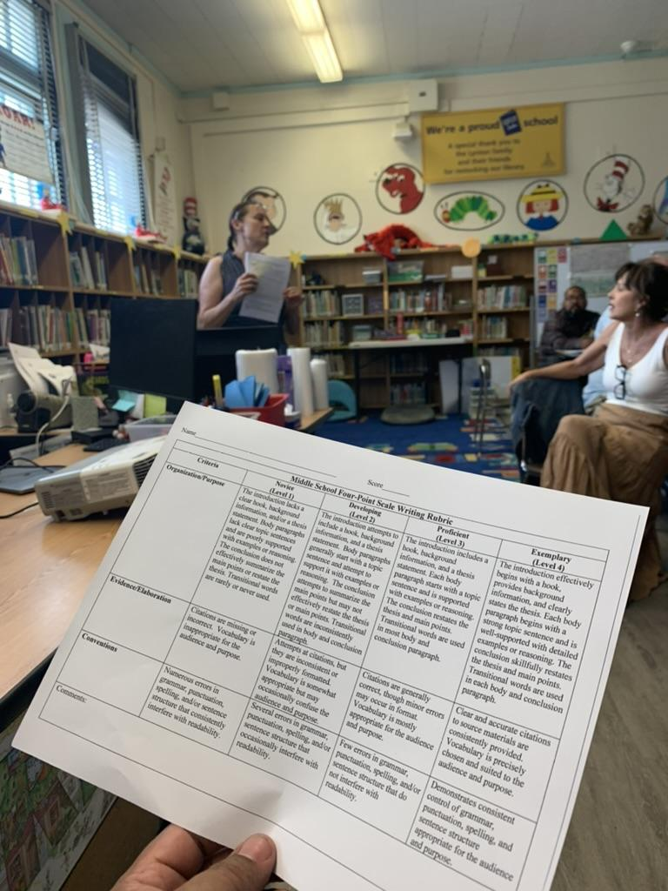
Professional Learning Community
Creating effective rubrics for various assignments provides clear expectations and consistent grading criteria. During PLC meetings, 1st - 5th grade teachers work to develop oral presentation rubrics that are specific to the work they are doing at the zoo. Pre-K and Kindergarten teachers develop developmentally appropriate rubrics. Our secondary teachers work on writing informational essays and geometry rubrics, understanding that clear expectations will assist our students in acquiring grade-level standards.
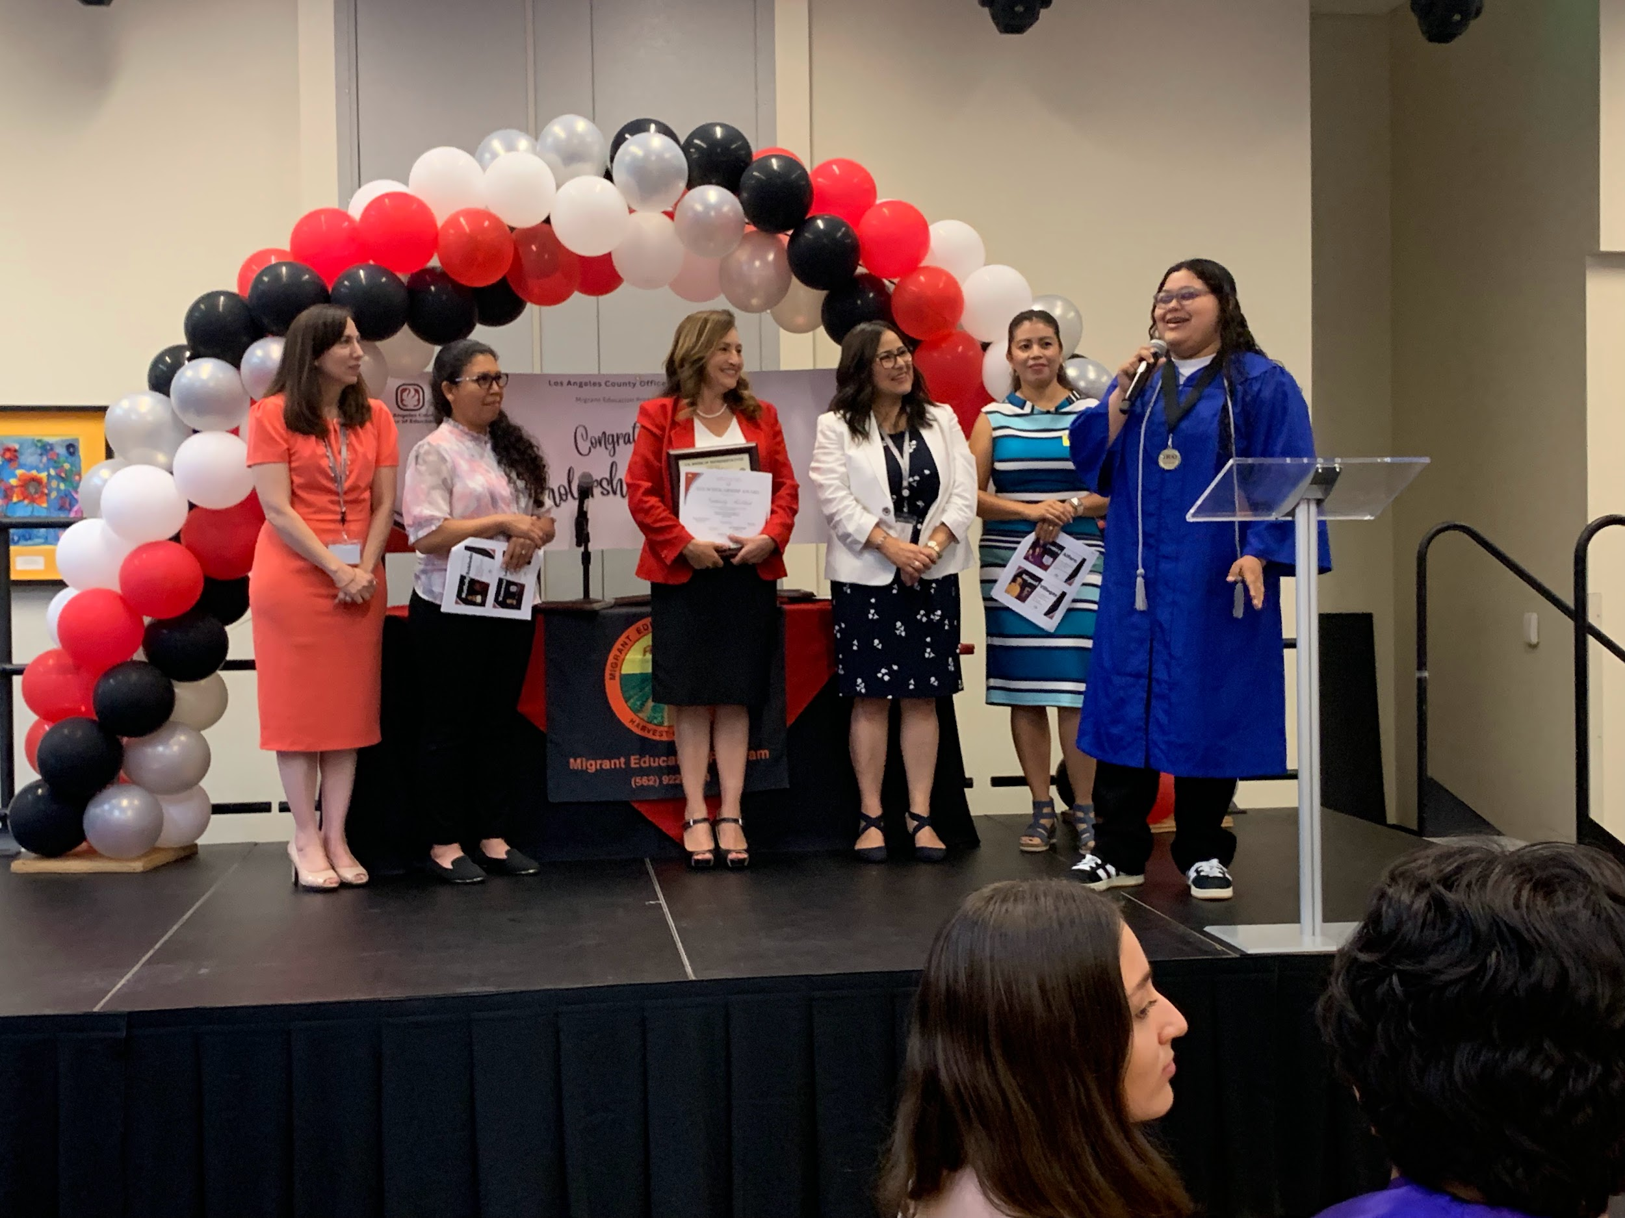
LACOE Scholarship Winners
Nathaly Robledo received a scholarship from the Los Angeles County Office of Education (LACOE) as she prepares to start school at California State University-Northridge. Speaking at the event LACOE Superintendent Dr. Debra Duardo provided encouragement based upon her life experiences.

For more information, please contact Victor Gonzalez at victor.gonzalez@lausd.net

VIRTUAL ENRICHMENT
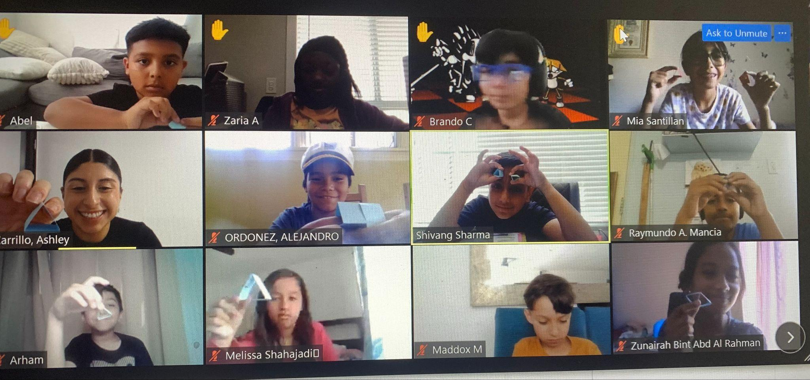
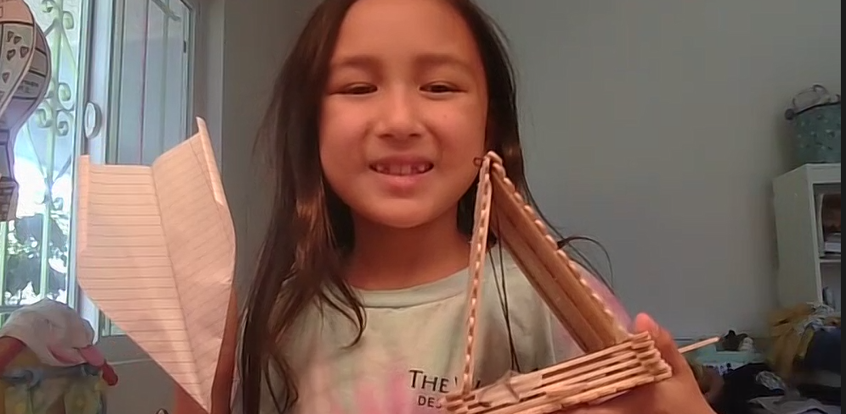
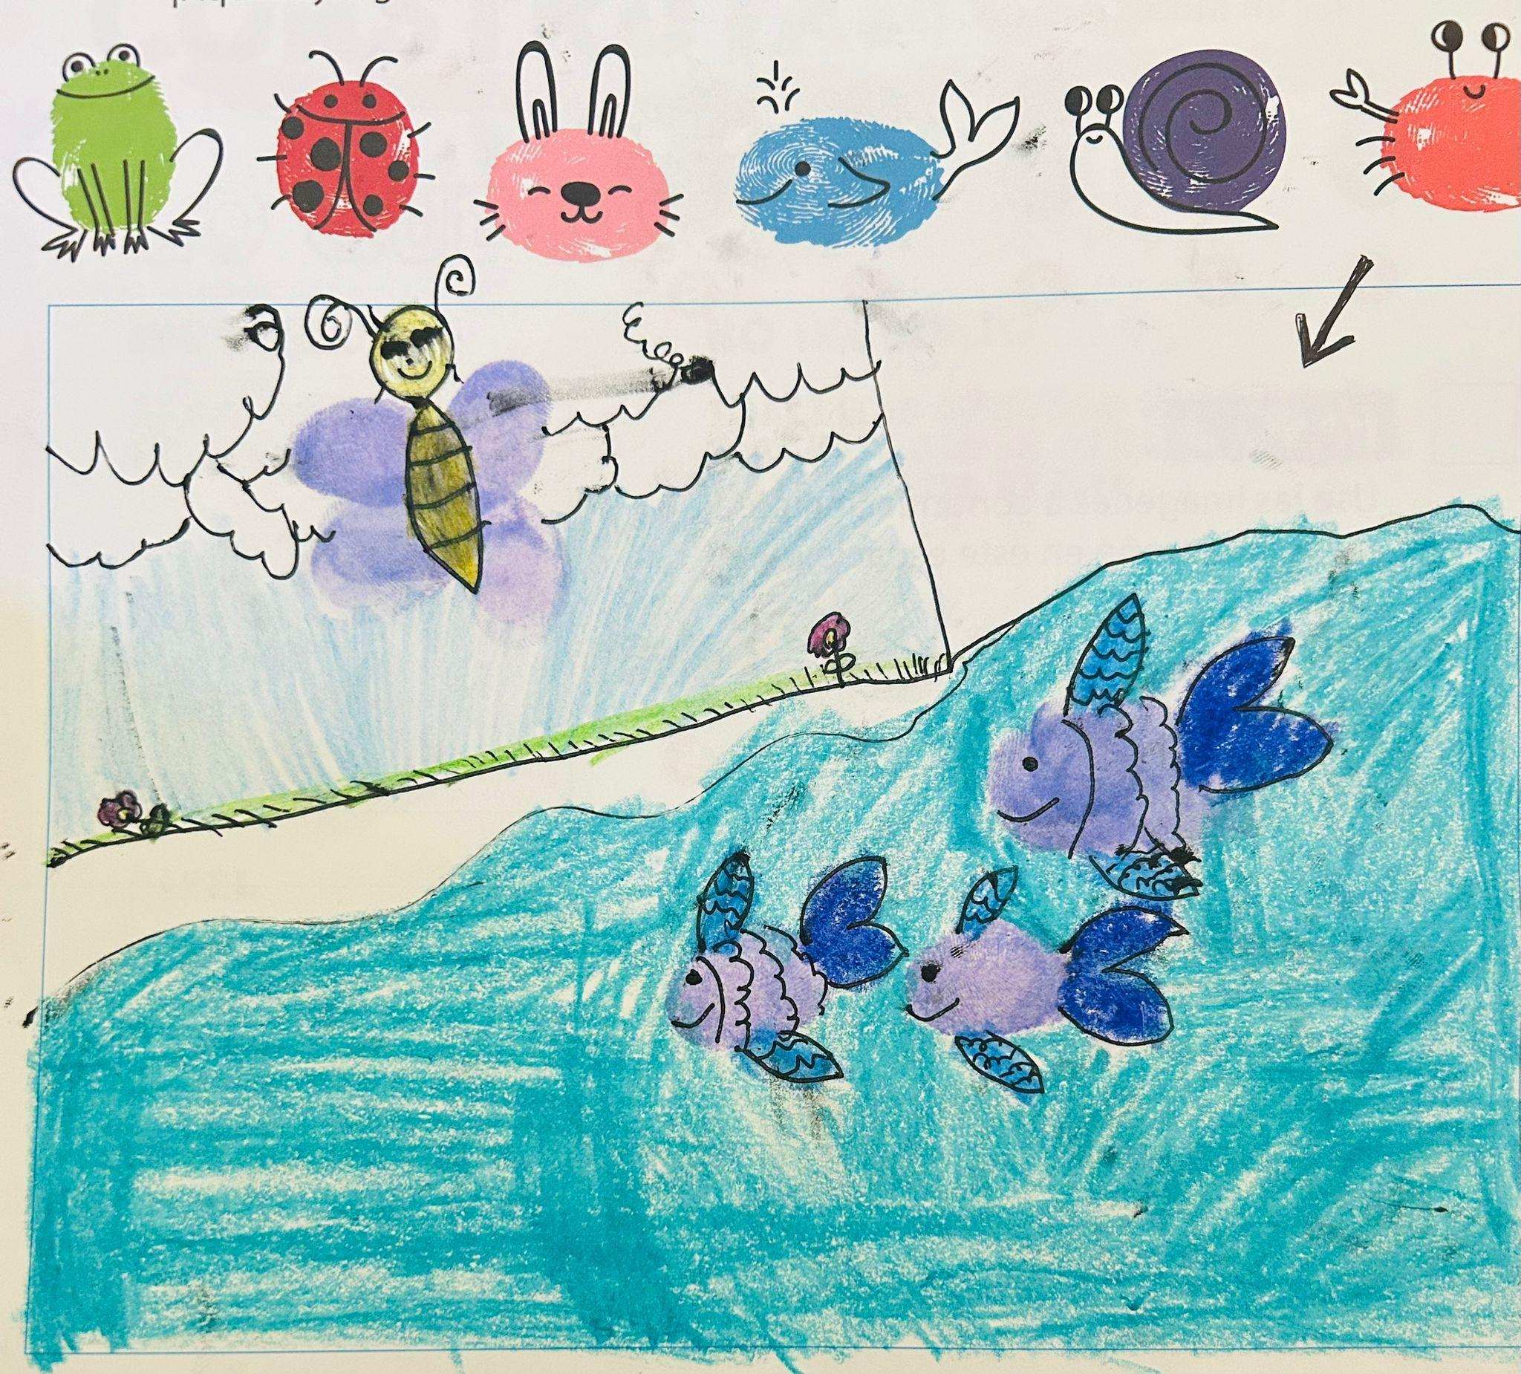
The STEAM Virtual Enrichment Program aims to inspire creativity, critical thinking, and problem-solving skills among students K-8 through hands-on exploration and interactive virtual sessions. By integrating diverse STEAM disciplines, this program encourages lifelong learning and prepares students for future academic and professional success in the modern world. The STEAM Virtual Enrichment Program offers students in grades Kindergarten through 8th an engaging educational experience focused on Science, Technology, Engineering, Arts, and Mathematics (STEAM). This program spans four days, with daily sessions lasting one hour each. In addition to virtual sessions, students receive a curated kit to facilitate hands-on learning experiences at home.

- 6,269 student enrollment for the virtual enrichment program (as of 7/12/24)

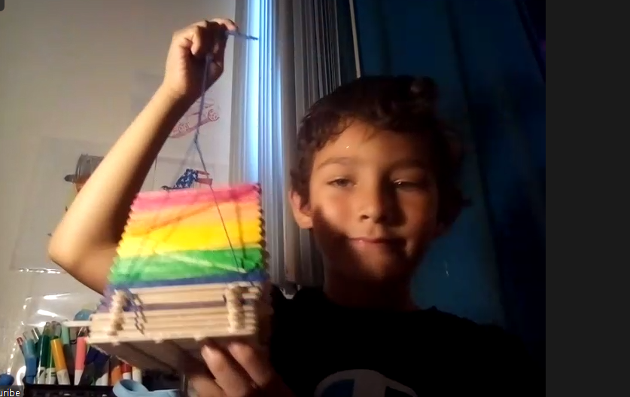
Program Details:
- Kindergarten: Students explore arts, and music, and engage in activities such as fingerprinting.
- 1st and 2nd Grades: Participants delve into the world of bird feeders, flight exploration, and maze design.
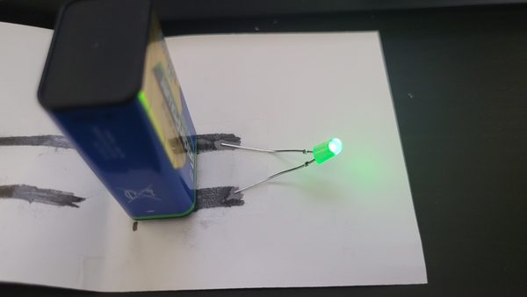
- 3rd and 4th Grades: Students investigate principles of hydraulics, design parachutes, and learn to navigate using maps and compasses.
- 5th and 6th Grades: Participants focus on building catapults, pneumatic lifts, and rolling vehicles, emphasizing practical applications of engineering concepts.
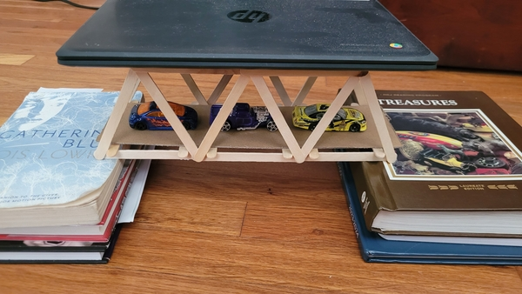
- 7th and 8th Grades: The curriculum includes the construction of gliders, truss bridges, and experimentation with electric circuits, fostering advanced engineering skills
For questions, contact Ayham Dahi, Science Coordinator at ayham.dahi@lausd.net.
To see a list of virtual enrichment course offerings, visit: enrichment.lausd.net

A-G INTERVENTION & SUPPORT: SUMMER TRANSITION SUPPORT HUBS
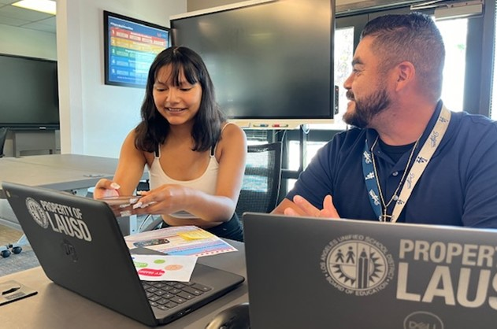
During the first weeks of the Summer Transition Hubs, 299 additional financial aid applications were completed, with students receiving personalized help from Hubs staff. In the week of July 8-12, many students needed support getting final transcripts submitted to their chosen colleges. Additionally, our grads are taking advantage of the support with community college enrollment and class registration.

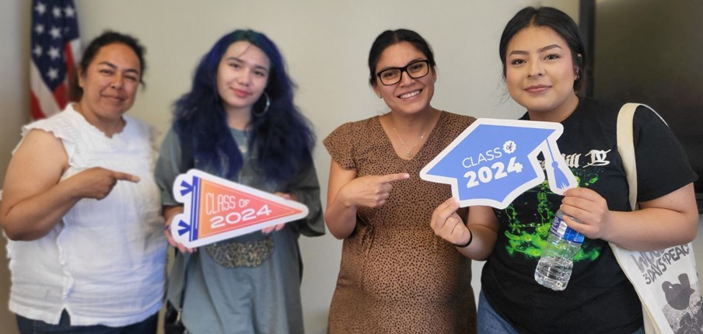
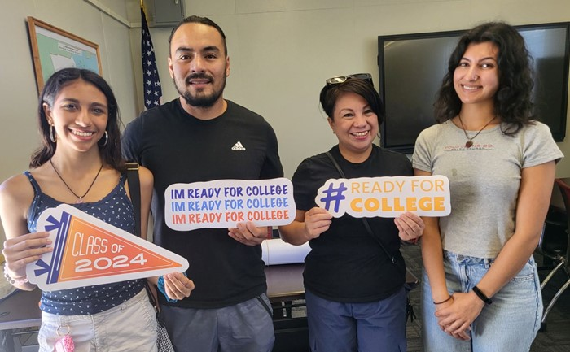

During Week 2 and Week 3, the Hubs have logged over:
- 6,400 emails & phone calls
- 60 in-person visits
- 48 virtual visits
For more information, please contact Carol Alexander, A-G Intervention and Support Director, at carol.alexander@lausd.net

GEAR UP 4 LA SUMMER SUPPORT
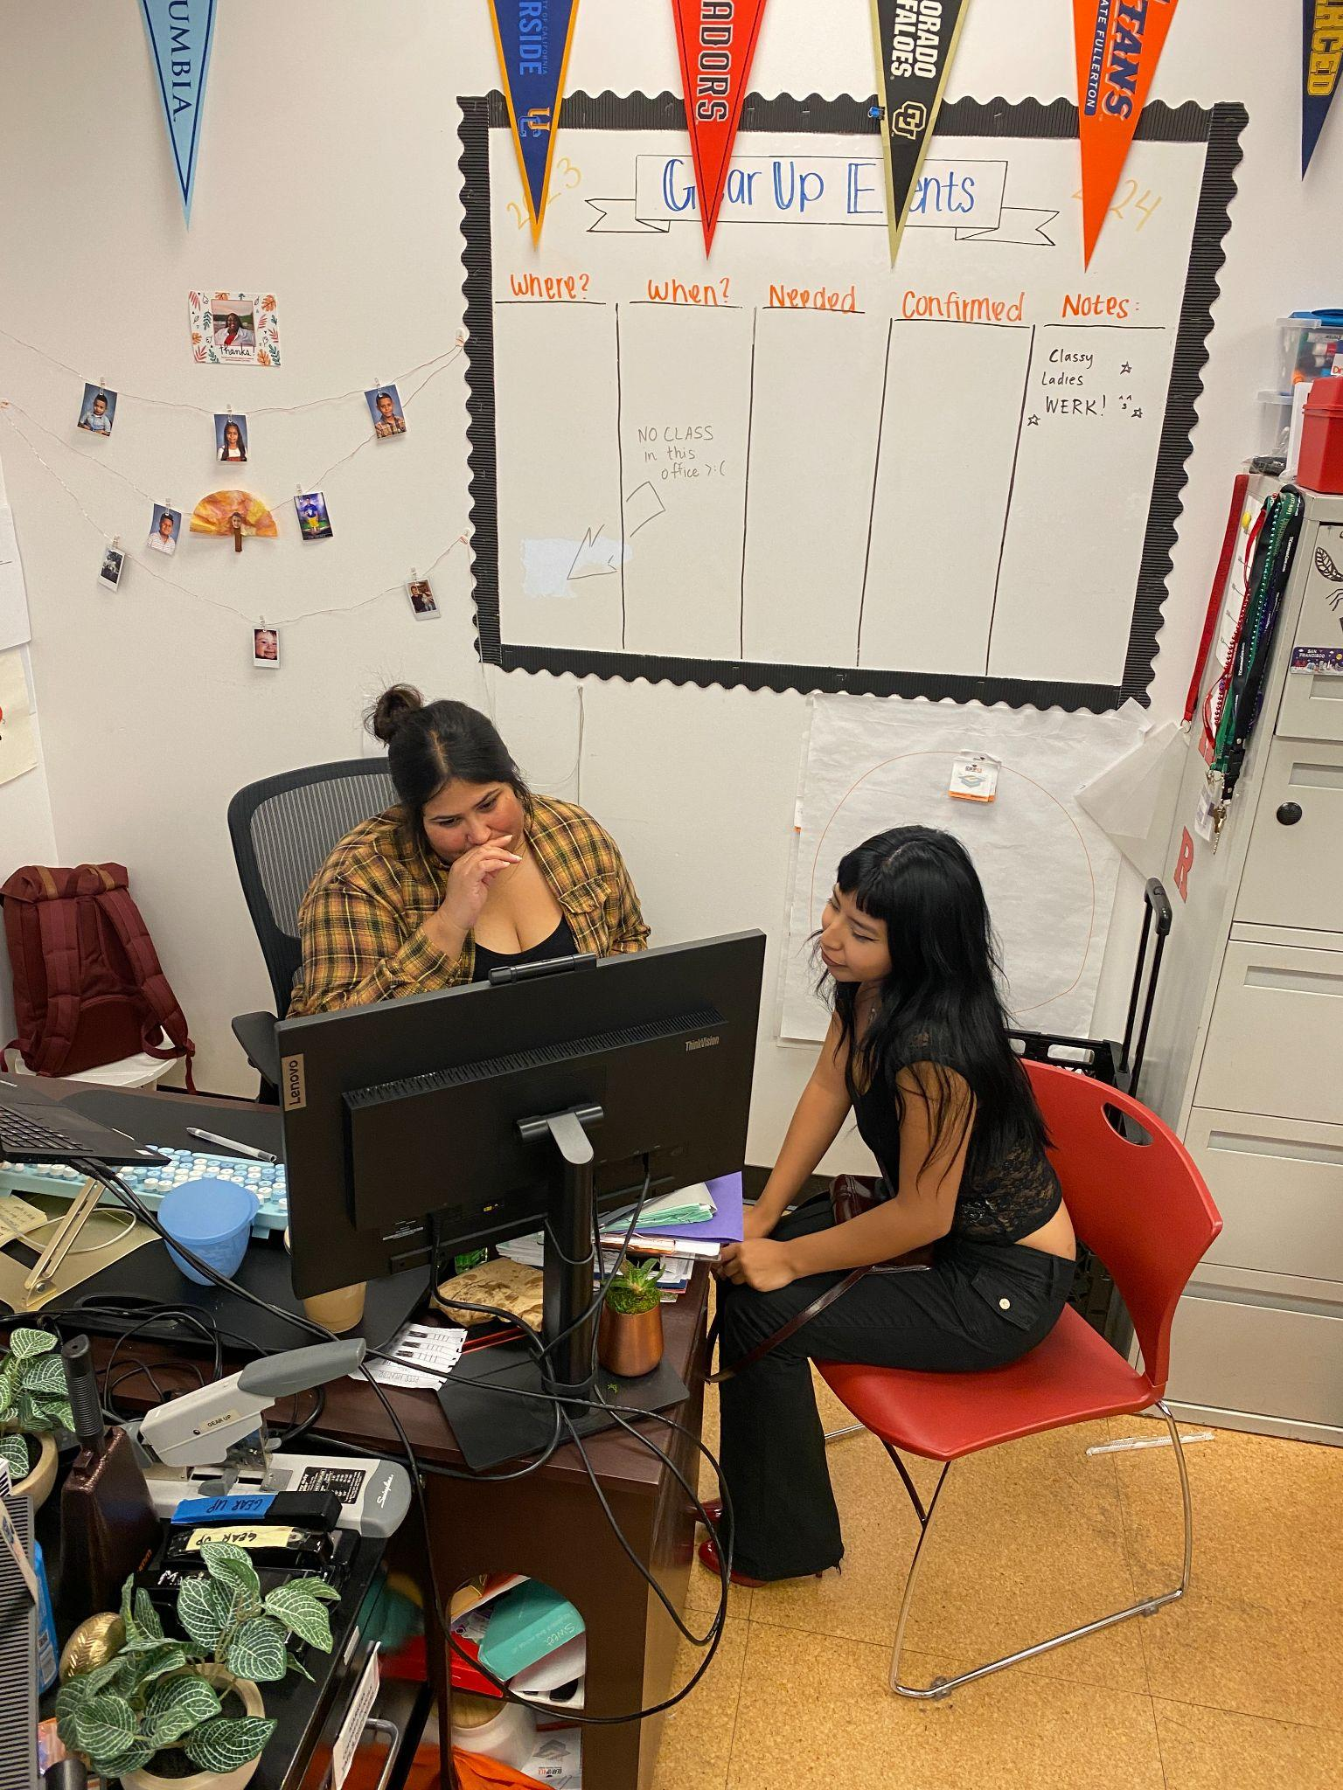
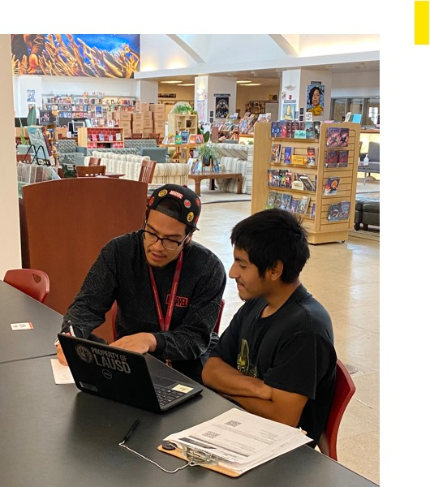
This summer, in partnership with eight institutions of higher education and the Chicano-a Latino-a Educational Foundation, 35 GEAR UP staff are providing proactive, transitional advising support to Class of 2024 students from high schools in all regions. Rising first-year college students have needed academic, financial, procedural, and social-emotional personalized advising to enter their chosen college this fall. Students are welcomed at any of the GEAR UP school sites for in-person consultation, and they can receive virtual support via dedicated online meetings with staff.
Thus far, the six GEAR UP sites have provided intensive support including over:
- 9,000 two-way communication texts, emails & phone calls
- 1,000 college orientation registration confirmations
- 200 in-person/virtual visits

For more information, please contact Jill Manning, Program Coordinator, at Jmann3@lausd.net.

CTE-LINKED LEARNING

Summer Internships
This summer 338 students are interning across the city of Los Angeles. Their placements include offices at Beaudry, regional offices, KLCS, Orthopedic Institute for Children, LA’s Best, Beyond the Bell sites, and other partner sites (view the full list of worksites here).
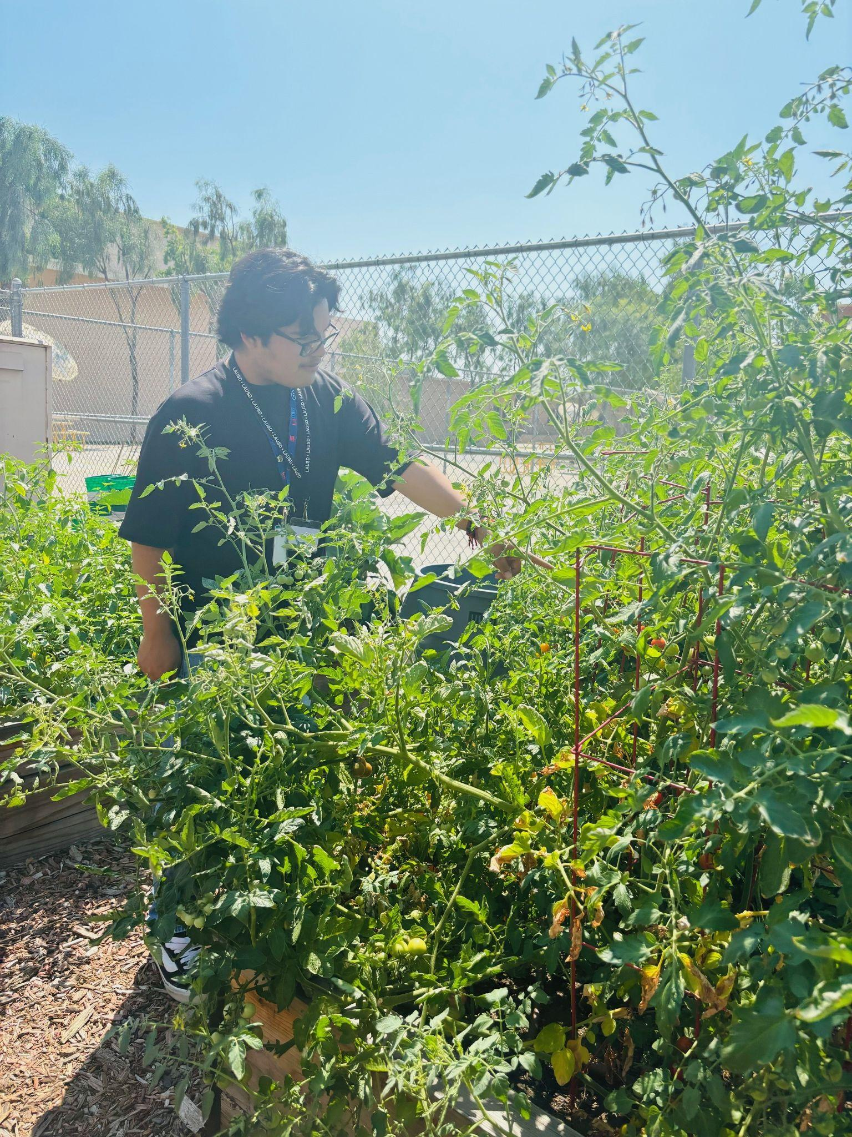
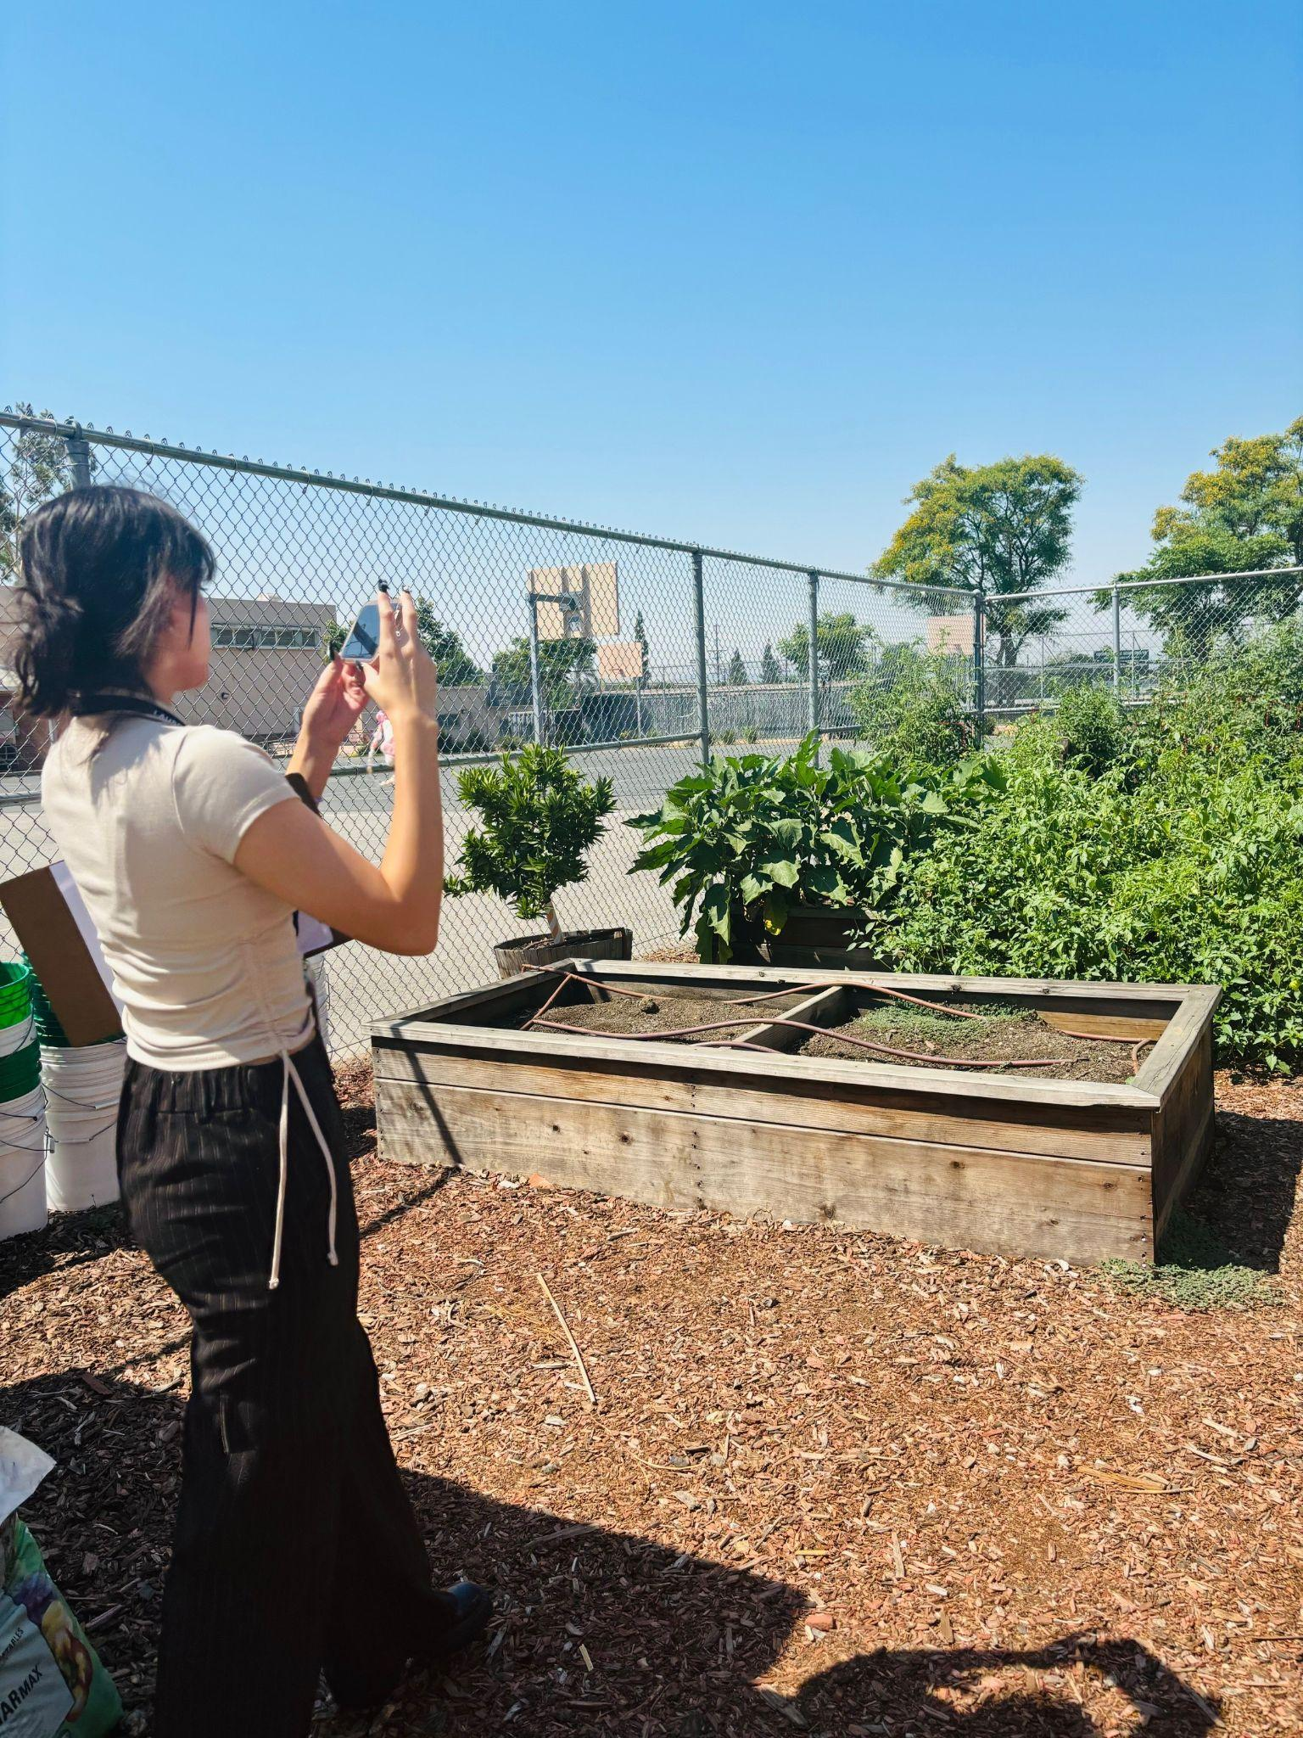
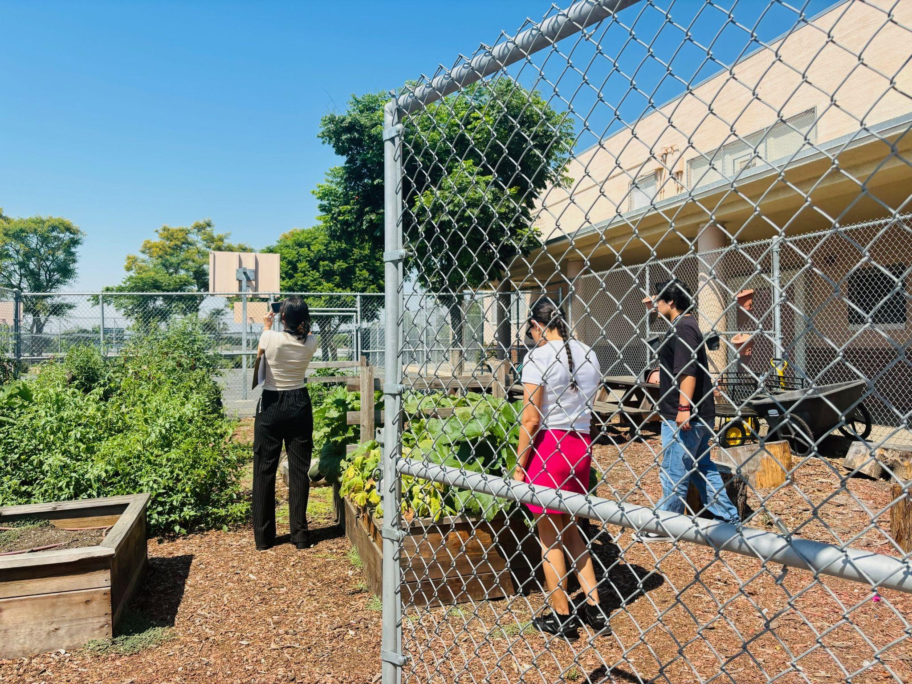
This week interns from the LAUSD Eco-Sustainability Office visited school sites with gardens. They visited Union Ave. Elementary, Stonehurst Ave. Elementary, San Fernando High, Castlebay Lane Charter, Superior Street Elementary, and Northridge Middle to conduct research on edible gardens.
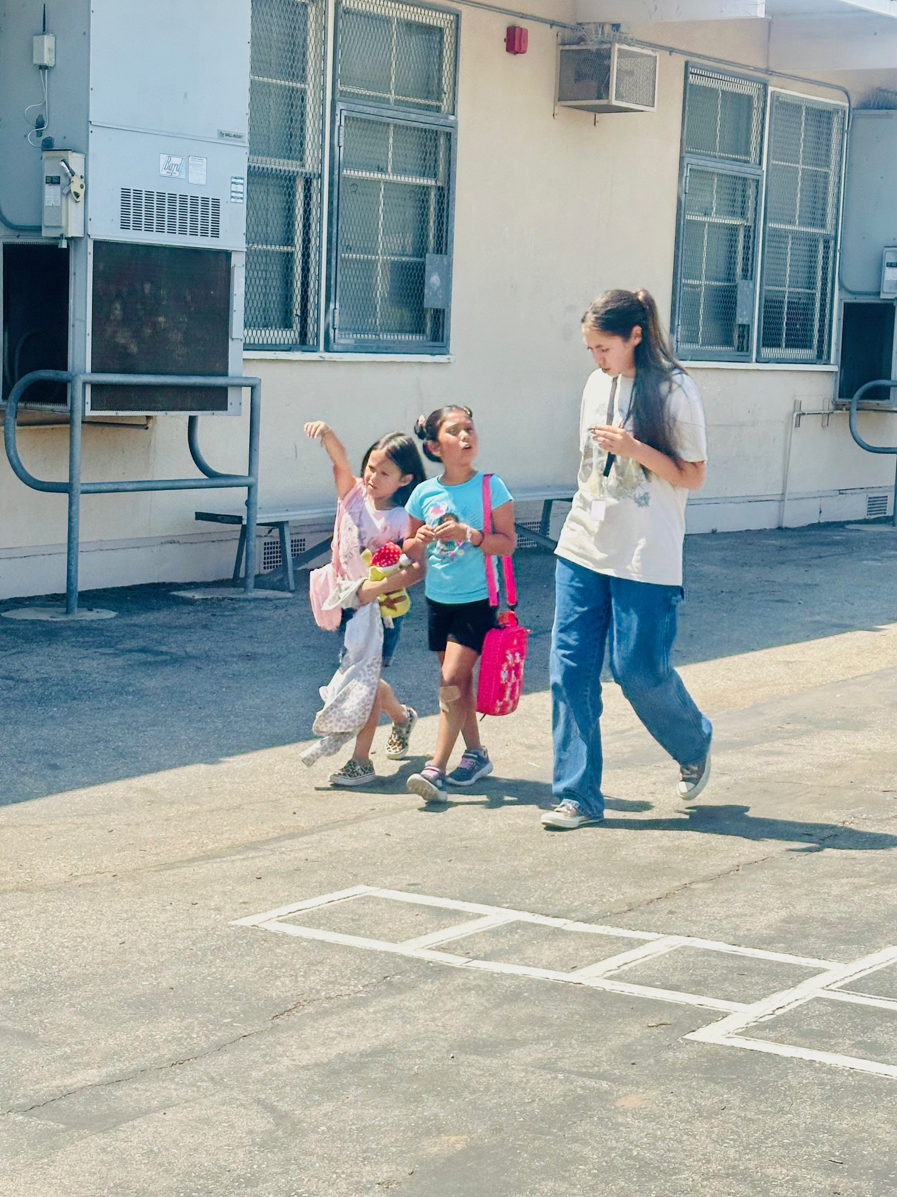
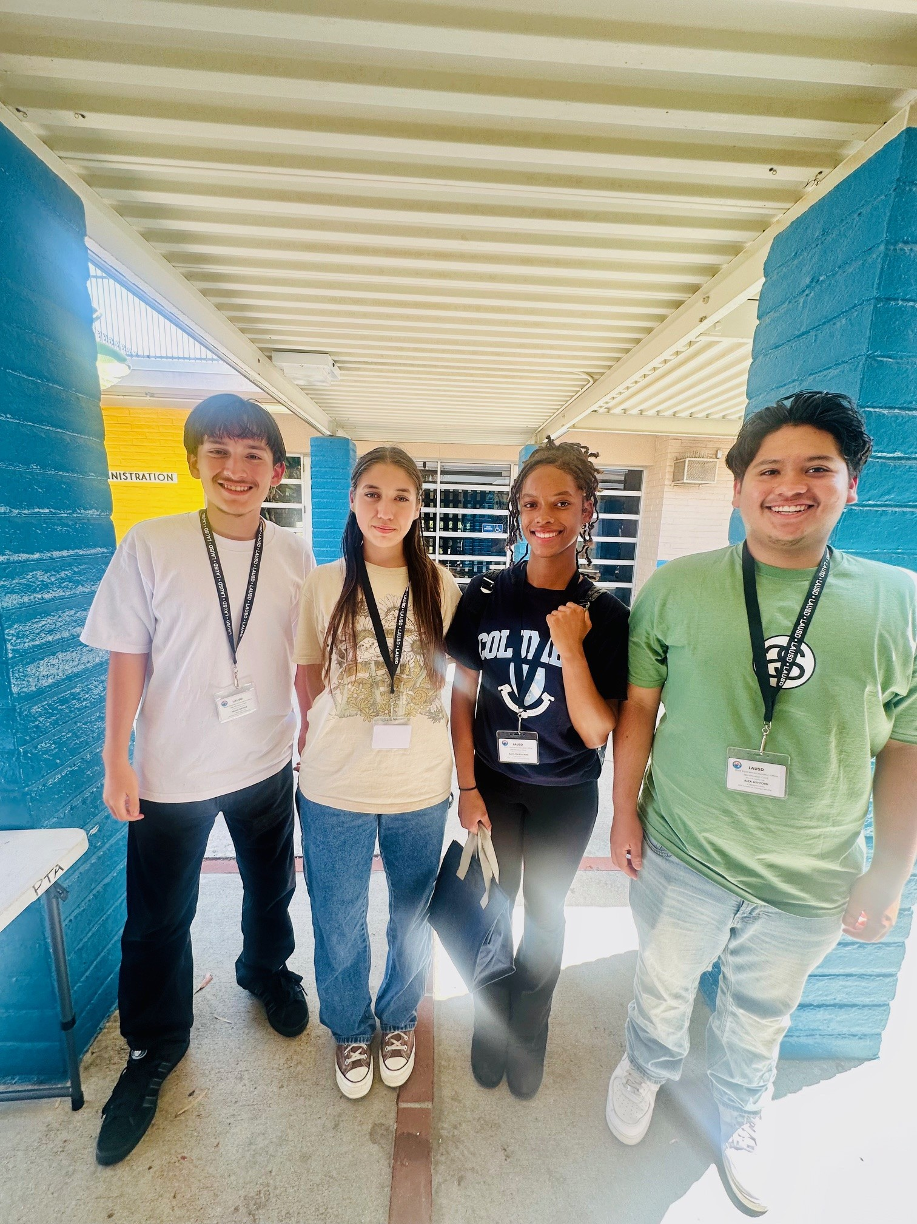
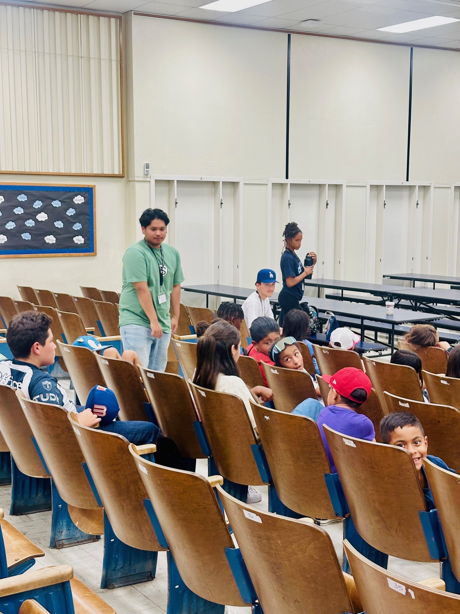
We also had a hard-working group of interns who are rising seniors in Carson AEE working for LA’s Best at Broad Avenue Elementary School.

For more information, please contact Esther Dabagyan at CTE-Linked Learning, esther.dabagyan@lausd.net.

CALIFORNIA STATE PRESCHOOL PROGRAM (CSPP)
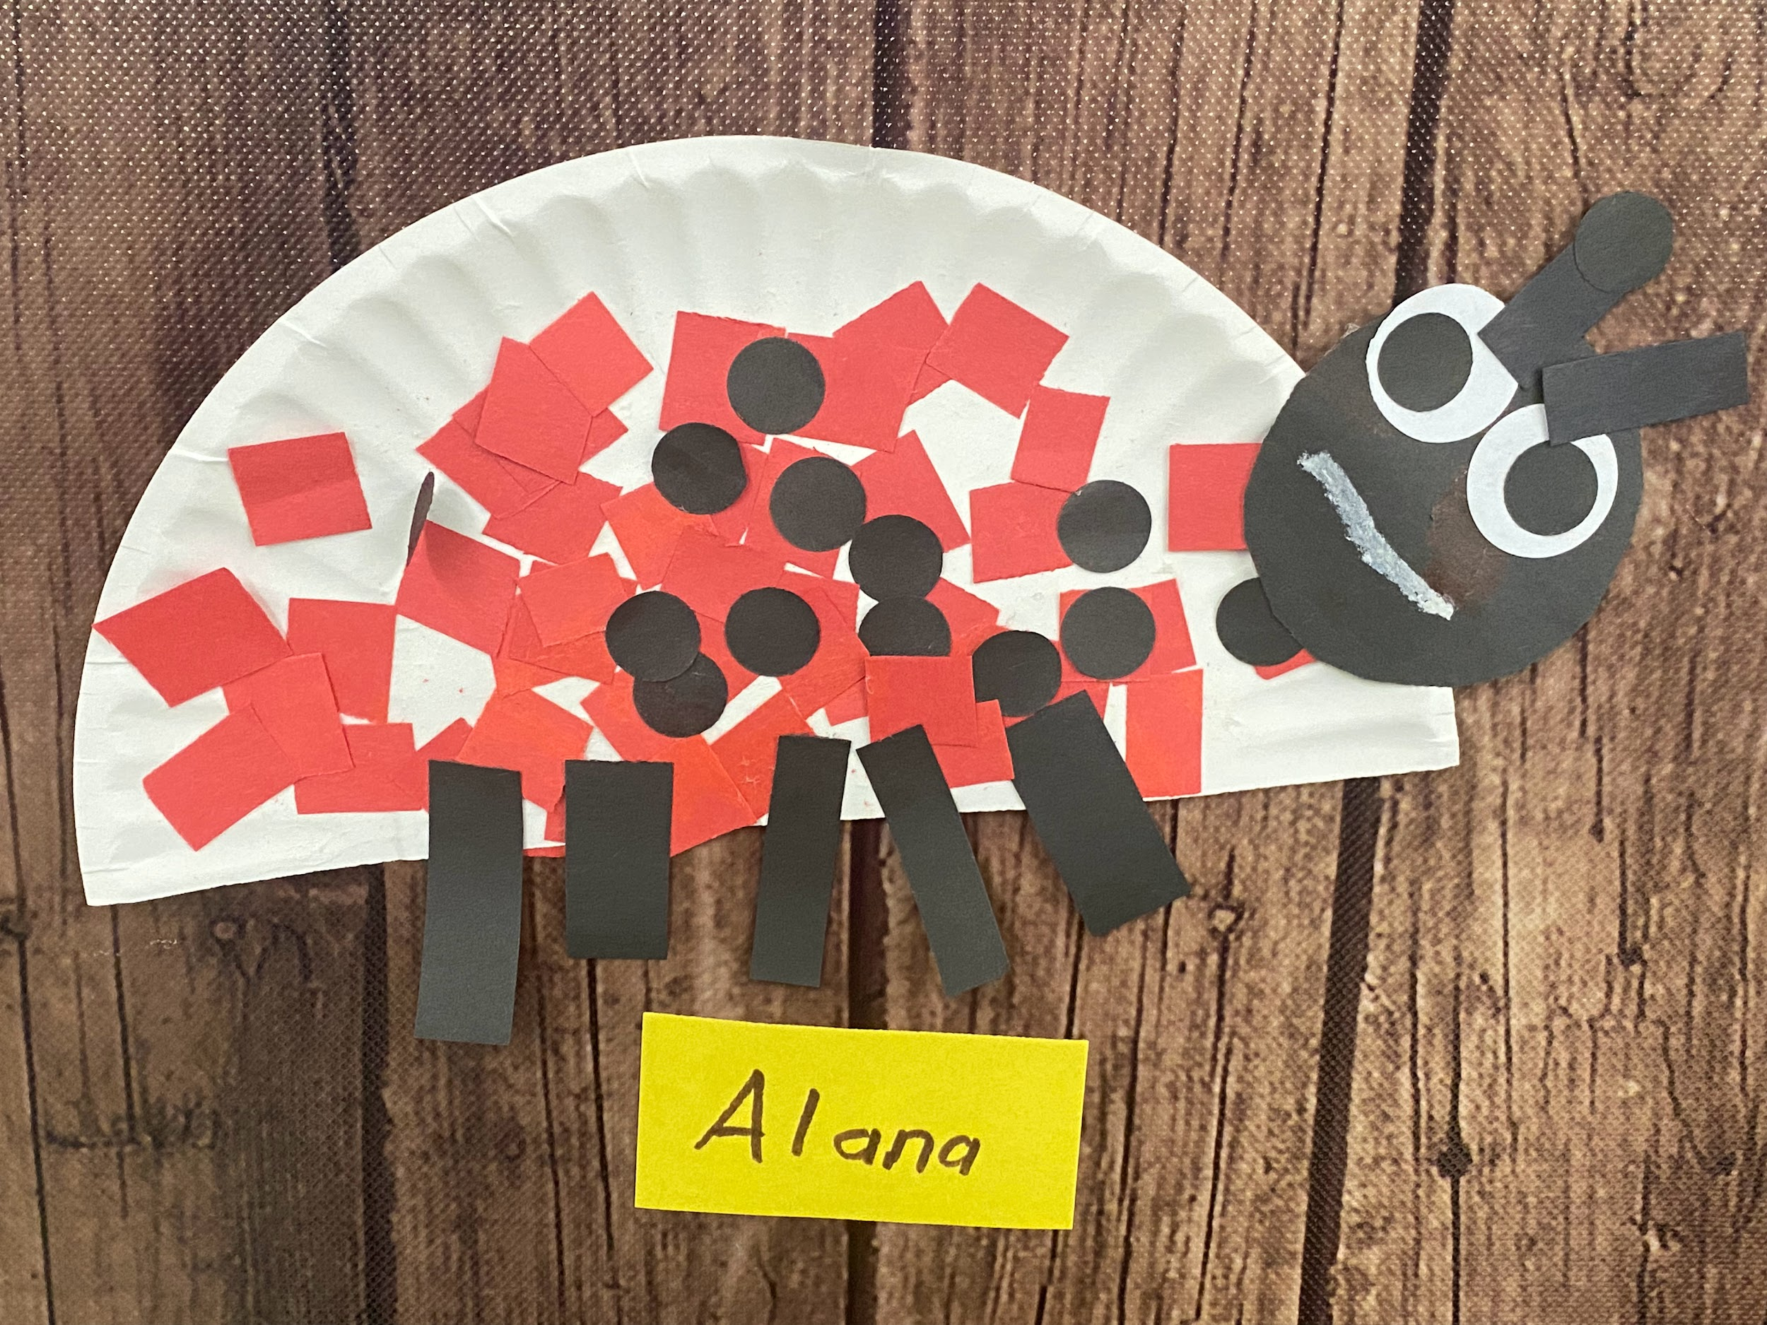
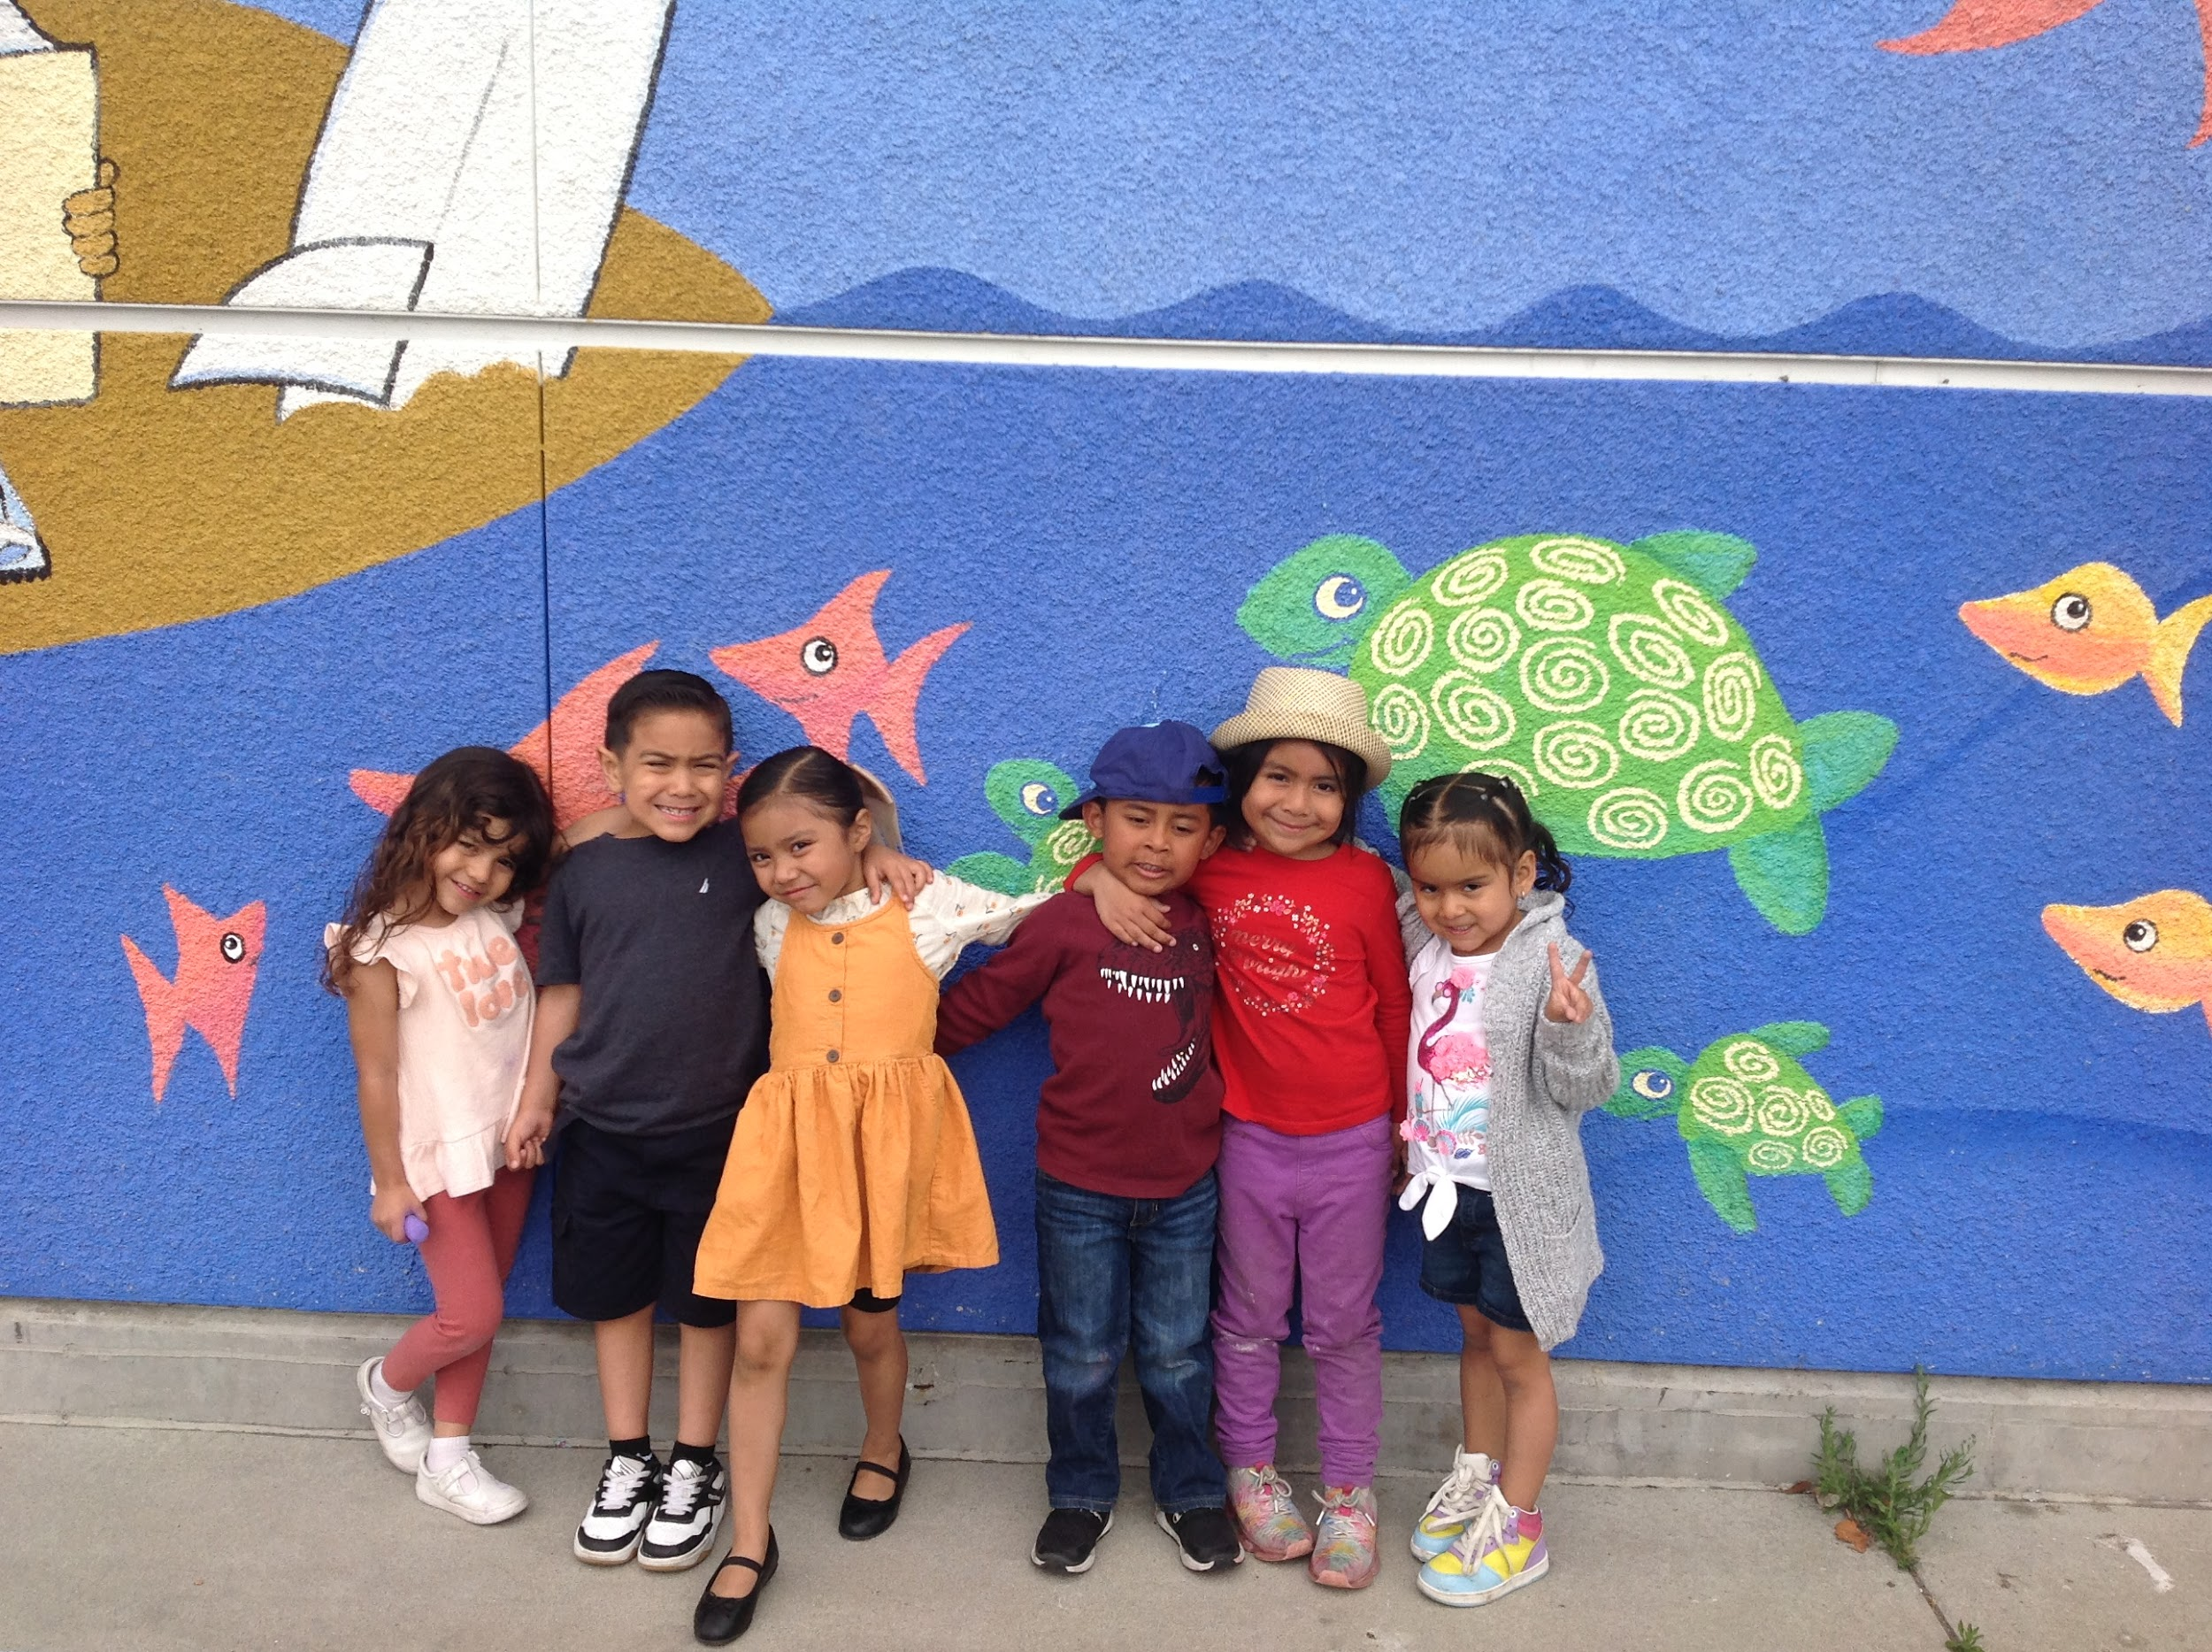
In preschool, we learn through play! 69 unique students enrolled for CSPP, as of 7/12/24.
- Attendance on 7/12/24 = 65

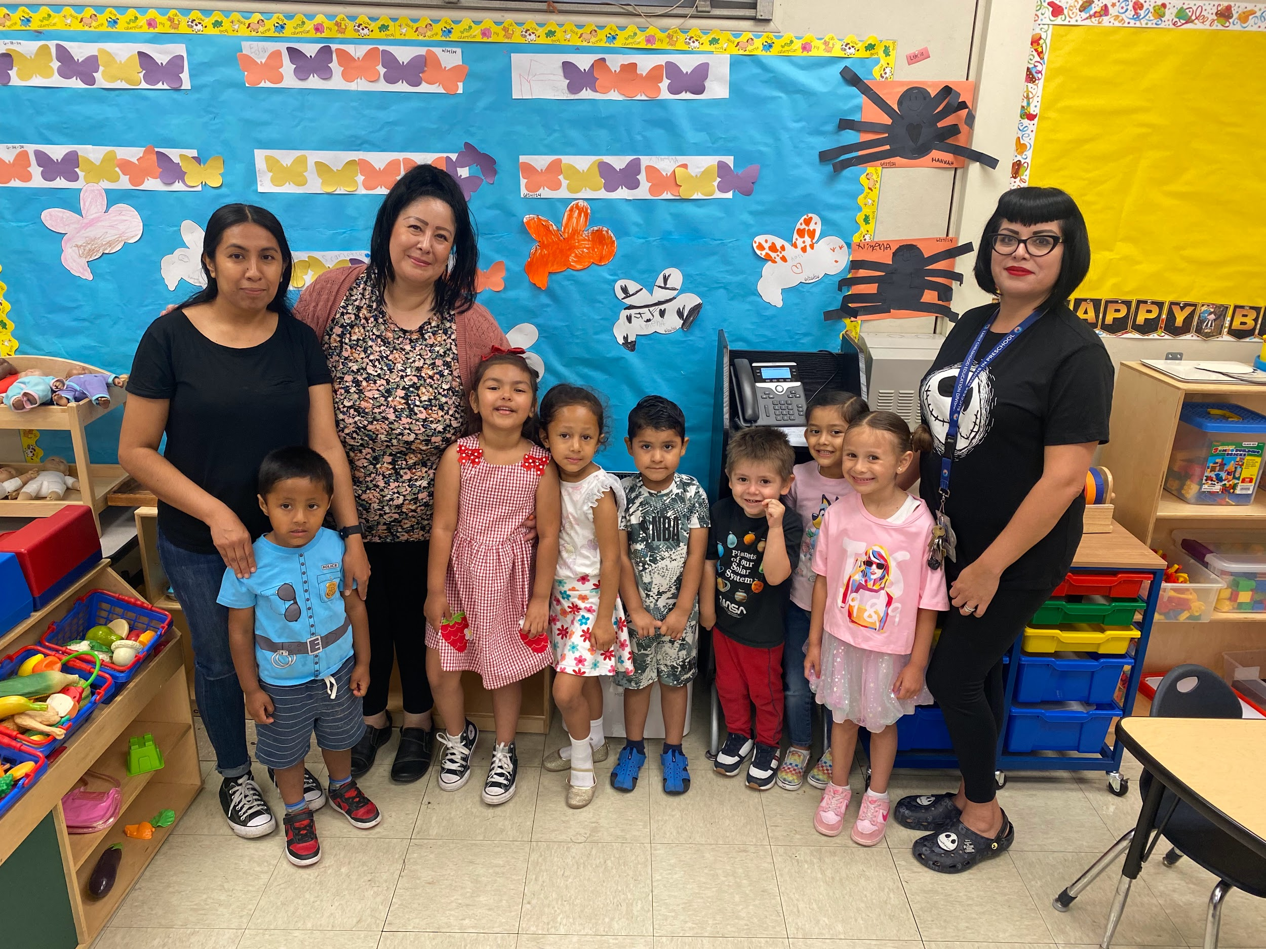
Play-based activities benefit our CSPP summer school students as they get ready for kindergarten. This approach fosters cognitive, social, and emotional development by allowing children to explore, experiment, and interact in a playful environment. It’s all about having fun with insects as we extend knowledge about shapes, colors, numbers, and letters! By engaging in play-based learning, our CSPP summer students develop a love for learning and gain confidence in their abilities, setting a strong foundation for their future educational journey. Activities like these help support enrollment and attendance.

Pictured are students from Hamasaki Elementary in Region East with their teacher, Ms. Julie Contreras, and Early Education Aides, Ms. Jessica Sanchez and Ms. Araceli Franco Arroyo. Students from George De La Torre Elementary in Region South, are pictured alongside their teacher, Ms. Rosa Diaz, and Early Education Center Aide, Ms. Sarah Mendez.

For more information, please contact Raul MORENO at ECED. rmore13@lausd.net, (213) 241-0157
*Source: ODA Summer 2024 PowerBI Dashboard

